The Patch Primary School

Emergency and Critical Incident Management Plan 2023-2024

53 Kallista-Emerald Road, The Patch, VIC, 3792
03 9756 7463 / the.patch.ps@education.vic.gov.au

Department of Education and Training

Date Approved: 31/08/2023

Purpose
The purpose of this Emergency and Critical Incident Management Plan (EMP) is to provide a detailed plan of how this school campus will prepare and respond to emergencies and critical incidents that may impact on student and/or staff health, safety and well-being and/or school operations.

Context
Schools have the authority to activate their EMPs when an event warrants a response. Schools should know how to access multiple information sources to support their preparedness for, response to and recovery from emergencies, including the VicEmergency app, https://www.emergency.vic.gov.au, emergency services and/or the Department of Education.

All principals and key school staff should download the VicEmergency app on their phone with a watch zone around their school to receive alerts and information regarding hazards and incidents in their vicinity.

Should the principal or school be made aware of an emergency in the local area, the principal or nominated person will consult the following sources for information:
- Call ‘000’ for life-threatening or time critical emergencies.
- Contact the Incident Support and Operations Centre (ISOC) on 1800 126 126.
- Seek support from your region/regional Manager, Operations and Emergency Management or Emergency Management Support Officer if required.
- Check the VicEmergency app or www.emergency.vic.gov.au for up to date information on warnings and incidents.
- Contact your Senior Education Improvement Leader.
- Check the Department of Education web site for incident updates.

Facility Profile
School Name/Campus Name | The Patch Primary School
Address | 53 Kallista-Emerald Road, The Patch, VIC, 3792
Phone | 03 9756 7463
Email | the.patch.ps@education.vic.gov.au
Fax | 0
DET Region | NORTH-EASTERN VICTORIA
DET Area | Outer Eastern Melbourne Area
LGA | Yarra Ranges (S)
BOM/Fire District | Central District
Is your school on Bushfire At- Risk Register? | Yes
Bushfire At-Risk Register Category | Category 2
Operating Hours | 8.30am to 4.30pm
Number of Students | 284
Number of Staff | 38
Number of Buildings | 9
Is the School a designated Neighborhood Safer Place? | No
Shelter-In-Place Location | Hall
On-site Evacuation Location | Hall
Off-site Evacuation Location | Oval
Typical method used for communications to school community | SMS / Email
Is this school has other services or users of the site? | Yes

Other Services/Users of Site
Service/User Name | Location | Number of Student or Visitor | Emergency Contact | Phone | Mobile
OSHClub | Hall, The Patch School, 53 Kallista Emerald Rd The Patch | 35 | 7.00am to 8.45am 3.00pm to 6.00pm Mon - Fri | 1300 395 735 | : 0400 708 773 A: 0437 533 102
The Patch Kinder TRY Australia | Main Building, The Patch School | 20-30 | Mon-Fri | 9752 1835 | 0408 657 671
Tradeflex | All buildings (cleaner) | 2 | 3.30pm - 8.00pm | 03 9827 9000 | 0423 759 478
Instramental Music Teacher | Main Building, The Patch School | 1 | 9am-3.30pm | 9756 7463 | 0408 102 542
Mosiac Horticulture | The Patch Primary School | 1 | 7am - 7pm & On call | 9752 0767 | 0487 208 532
Instramental Music Teacher | Main Building, The Patch School | 1 | 9am - 3.30pm | 9752 7463 | 0423 765 312
Instramental Music Teacher | Main Building, The Patch School | 1 | 9am - 3.30pm | 9752 7463 | 0408 539 523
Instramental Music Teacher | Main Building, The Patch School | 1 | 9am - 3.30pm | 9756 7463 | 0407 647 511
Instramental Music Teacher | Main Building, The Patch School | 1 | 9am - 3.30pm | Eddie Cole | 0417 152 947
The Secure Base | The Nest | 1 | As needed (9am-5pm) | 9756 7463 | 0456 607 411
Emerald Centre for Hope and Outreach | The Nest | 1 | Tues & Fri (8.45am - 4pm) | 9756 7463 | 0431 584 439

Building Information Summary

Telephones (landlines)
Location | Number
The Patch School | (03) 9756 7463
All classrooms have telephone access. Internal phone directory provided.
Kindergarten | (03) 9752 1835

Alarms
Description | Location | Monitoring  Company | Number
Fire | Staffroom | N/A | Switch the 'off' button
Intrusion | Each room | DET SSU | Panel in Resource Room in behind Principal's office.
Other

Utilities
Description | Location | Service  Provider | Location of shutoff  Instructions
Gas / Propane | Meter located next to entry gate. | Multinet | At meter located next to entry gate. Key located in key register
Water | Front of property close to 51 Kallista Emerald Rd (Gravel Car Park side) | Yarra Valley Water | Turn tap clockwise to tighten tap & shut off water supply
Electricity | Large cabinet at front of property. | SPAusnet | No access except by electrical industry key (key register in main switchboard)

Sprinkler System
Control Valve Location | N/A
Shutoff Instructions Location | N/A

Boiler Room
Location | West end of main building adjacent to Classroom 4
Access | Via Master Key 1 (MK1)

Emergency Power System
Type | Red Series DGA20EM Generator 20KVA Bio diesel
Location | Below Hall / SIP front entrance in locked cage
Provides power to | The Hall / SIP
Shutoff Instructions Location | 2 x laminated sheets - 1 in the Hall / SIP & 1 in the evacuation trolley (office). Steve to supply.

Building and Site Hazards
Location | Number
Fuel and chemicals | Store Room 78 at west end of main building
Cleaning products | Cleaner's store room next to unisex toilets in main building 'CLNR 23' SAMS Plan

Additional Profile Information
Additional Info | 2023 / 2024 will see various building works being completed around the school due to the upgrade.

Drill Schedule
School Term | Drill Type | Contact Person | Schedule Date | Actual Date
Term 1,2023 | Evacuation to Hall | Debra Herrmann | 15/02/2023 | 15/02/2023
Term 1,2023 | Shelter in Place (Bushfire) | Debra Herrmann | 10/03/2023 | 10/03/2023
Term 2, 2023 | Shelter in Place (Bushfire) | Michelle Rayner | 16/06/2023 | 16/06/2023
Term 3, 2023 | Evacuation to offsite location (oval) | Debra Herrmann | 07/09/2023
Term 4, 2023 | Shelter in Place (Fire) | Michelle Rayner | 23/11/2023 | 15/02/2023
Term 1, 2024 | TBA | New Principal | 22/02/2024
Term 2, 2024 | TBA | New Principal | 20/06/2024

First Aid Training
Staff Member | Training Completed | Date Qualified To
BLANDTHORN, Tania | Apply First Aid / CPR | 16/12/2025
deVREEZE, Nina | Apply First Aid / CPR | 16/12/2025
HERRMANN, Debra | Apply First Aid / CPR | 16/12/2025
HOLDEN, Jessica | Apply First Aid / CPR | 04/11/2022
MCDONALD, Kellie | Apply First Aid / CPR | 16/12/2025
ALLAN, Deb | Apply First Aid / CPR | 16/12/2025
MILLER, Sarah | Apply First Aid / CPR | 16/12/2025
BURKE, Haley | Apply First Aid / CPR | 16/12/2025
MERCIECA, Yale | Apply First Aid / CPR | 16/12/2025
ROBINSON, Karen | Apply First Aid / CPR | 16/12/2025
SANGSTER, Alesha | Apply First Aid / CPR | 16/12/2025
SIMPSON Jennie | Apply First Aid / CPR | 16/12/2025
WALSH, Sophia | Apply First Aid / CPR | 16/12/2025
SMALL Kim | Provide First Aid (HLTAID12 / HLTAID011 / HLTAID0010) | 14/10/2024
AGIS Kent | Apply First Aid / CPR | 16/12/2025
GOULD Pauleen | Apply First Aid / CPR | 16/12/2025
KAINBACHER Judith | Apply First Aid / CPR | 16/12/2025
SMALL Kim | Epilepsy: An Intro to the understanding & Managing Epilepsy for Educators
SMALL Kim | CPR (HLTAID0009) | 16/12/2023
SMALL Kim | ASCIA anaphylaxis e-training VIC 2021-2 | 09/11/2024
Small Kim | 22578VIC First Aid Management of Anaphylaxis | 28/04/2025
MOLENAAR | 22578VIC First Aid Management of Anaphylaxis | 28/04/2025
GOULD Pauleen | ASCIA anaphylaxis e-training VIC 2021-2 | 18/07/2024
ALLAN Deb | ASCIA anaphylaxis e-training 2021-2 | 28/07/2024
BLANDTHORN Tania | ASCIA anaphylaxis e-training 2021-2 | 18/07/2024
BURKE Haley | ASCIA anaphylaxis e-training 2021-2 | 18/07/2024
deVREEZE Nina | ASCIA anaphylaxis e-training 2021-2 | 21/07/2024
HERRMANN Debra | ASCIA anaphylaxis e-training 2021-2 | 05/08/2024
HOLDEN Jess | ASCIA anaphylaxis e-training 2021-2 | 05/08/2024
GUNN Andrea | ASCIA anaphylaxis e-training 2021-2 | 01/08/2024
KOELEWYN Karen | ASCIA anaphylaxis e-training 2021-2 | 01/08/2024
KUKURUZOVIC Grace | ASCIA anaphylaxis e-training 2021-2 | 05/08/2024
MCDONALD Kellie | ASCIA anaphylaxis e-training 2021-2 | 27/07/2024
MERCIECA Yale | ASCIA anaphylaxis e-training 2021-2 | 05/08/2024
PIESSE WALTON Oliver | ASCIA anaphylaxis e-training 2021-2 | 02/08/2024
RYAN Nicola | ASCIA anaphylaxis e-training 2021-2 | 26/07/2024
SIMPSON Jennie | ASCIA anaphylaxis e-training 2021-2 | 15/07/2024
SIMPSON Bec | ASCIA anaphylaxis e-training 2021-2 | 19/07/2024
WALSH Sofia | ASCIA anaphylaxis e-training 2021-2 | 09/08/2024
GRAHAM Molly | ASCIA anaphylaxis e-training 2021-2 | 19/07/2024
GUNN Andrea | Provide First Aid HLTAID12 / HLTAID011 / HLTAID0010 | 14/10/2024
AGIS Kent | Epilepsy: An Intro to the understanding & Managing Epilepsy for Educators
GOULD Pauleen | Epilepsy: An Intro to the understanding & Managing Epilepsy for Educators
ALLAN Deb | Epilepsy: An Intro to the understanding & Managing Epilepsy for Educators
BLANDTHORN Tania | Epilepsy: An Intro to the understanding & Managing Epilepsy for Educators
BURKE Haley | Epilepsy: An Intro to the understanding & Managing Epilepsy for Educators
CHISWELL, Hayden | Epilepsy: An Intro to the understanding & Managing Epilepsy for Educators
deVREEZE Nina | Epilepsy: An Intro to the understanding & Managing Epilepsy for Educators
HERRMANN Deb | Epilepsy: An Intro to the understanding & Managing Epilepsy for Educators
HOLDEN Jess | Epilepsy: An Intro to the understanding & Managing Epilepsy for Educators
KAINBACHER Jude | Epilepsy: An Intro to the understanding & Managing Epilepsy for Educators
KUKURUZOVICGrace | Epilepsy: An Intro to the understanding & Managing Epilepsy for Educators
MCDONALD Kellie | Epilepsy: An Intro to the understanding & Managing Epilepsy for Educators
MERCIECA Yale | Epilepsy: An Intro to the understanding & Managing Epilepsy for Educators
MILLER Sarah | Epilepsy: An Intro to the understanding & Managing Epilepsy for Educators
NORTH David | Epilepsy: An Intro to the understanding & Managing Epilepsy for Educators
PIESSE WALTON Oliver | Epilepsy: An Intro to the understanding & Managing Epilepsy for Educators
RAYNER Michelle | Epilepsy: An Intro to the understanding & Managing Epilepsy for Educators
RYAN Nicola | Epilepsy: An Intro to the understanding & Managing Epilepsy for Educators
SANGSTER Alesha | Epilepsy: An Intro to the understanding & Managing Epilepsy for Educators
SIMPSON Bec | Epilepsy: An Intro to the understanding & Managing Epilepsy for Educators
ZWIERS Josie | Epilepsy: An Intro to the understanding & Managing Epilepsy for Educators
TOONE Lesley | Epilepsy: An Intro to the understanding & Managing Epilepsy for Educators
ZWIERS Josie | ASCIA anaphylaxis e-training 2021-2 | 12/08/2024
SANGSTER Alesha | ASCIA anaphylaxis e-training 2021-2 | 05/08/2024
ROBINSON Karen | ASCIA anaphylaxis e-training 2021-2 | 05/08/2024
RAYNER Michelle | ASCIA anaphylaxis e-training 2021-2 | 29/07/2024
Anna McDonnell | Apply First Aid / CPR | 16/12/2025
Bec Hill | Apply First Aid / CPR | 16/12/2025
Paula Woodward | Apply First Aid / CPR | 16/12/2025
David North | Apply First Aid / CPR | 16/12/2025
Lukas Battey | Epilespy: Introduction to Understanding & Managing Epilepsy | 03/07/2023
Indigo Sangster | ASCIA anaphylaxis e-training 2023 | 22/08/2023

Other Training Record
Staff Member | Training Type | Date
RYAN, Nicola | Diabetes Glucagon Training/ Diabetes at School | 24/04/2019
BLANDTHORN, Tania | Diabetes Glucagon Training/ Diabetes at School | 24/04/2019
KAINBACHER, Judith | Diabetes Glucagon Training/ Diabetes at School | 24/04/2019
BURKE, Haley | Diabetes at School | 04/02/2020
FALLON, Cheryl | Diabetes at School | 04/02/2020
SIMPSON, Rebecca | Diabetes at School | 09/10/2020
SIMPSON , Jennie | Diabetes at School | 09/08/2021
SIMPSON, Rebecca | Level 1 - Type 1 Diabetes in School 2020 Level 2 - Advanced Type 1 in Schoo 2020 Level 3 - Insulin Administration in School 2020 | 26/09/2020
Yale Mercieca | T1D Level 1 - Essential care of all students with Type 1 Diabetes 2023 | 14/02/2023
Yale Mercieca | T1D Level 2 - Essential care of the individual student with Type 1 Diabetes 2023 | 14/02/2023
Kim Small | TD1 Level 1 - Essential care of all students with Type 1 Diabetes 2023 | 11/08/2023
Kim Small | TD1 Level 2 - Essential care of the individual student with Type 1 Diabetes 2023 | 11/08/2023

Students or Staff with Additional Needs
To ensure adherence to the provisions of the Information Privacy Act 2000 you should not record personal details here.
Add summary of those with additional needs or medical conditions below, without including personal details.
Category | Number of Staff | Number of Students
Anaphylaxis | 1 | 1
Asthma | 1 | 54
Autism | 0 | 15
Severe behaviour disorder | 0 | 7
Diabetes | 0 | 1
Intellectual disability | 0 | 4
Severe Language | 0 | 1
Epilepsy | 0 | 2
Heart Condition | 0 | 2
Mobility issues | 0 | 1
Bilateral Radial Dysplasia | 0 | 1

Emergency Kit Checklist
Checklist | Yes / No
Student data and parent contact information (contained in EMP) | Yes
Student and staff with additional needs list (contained in EMP) including any student medications | Yes
Staff contact information | Yes
List of staff on the IMT | Yes
Facility keys | Yes
Standard portable First Aid Kit. Refer to First Aid Kits Contents Checklist | Yes
Whistle | Yes
Megaphone | Yes
Copy of facility site plan and EMP including evacuation routes | Yes
Emergency IPAD with sim to use Compass | Yes
Excursions/Camps First Aid backpack | Yes
Internet ready smart phone with Radio 774, VicEmergency and other relevant apps (with Charger) | Yes
School General Medicine Tub AND EpiPen bags x 2 | Yes
Bottled Water (located already at Shelter in Place Exp 02/08/2023) | Yes
Torch with replacement batteries & 1 Wind up torch. (located at Shelter in Place) | Yes
Daily Students Medication kept under front counter | Yes

Review Emergency kit checked date

Date emergency kit checked | 01/02/2023
Next check date | 16/11/2023

Incident Management Team
IMT Structure
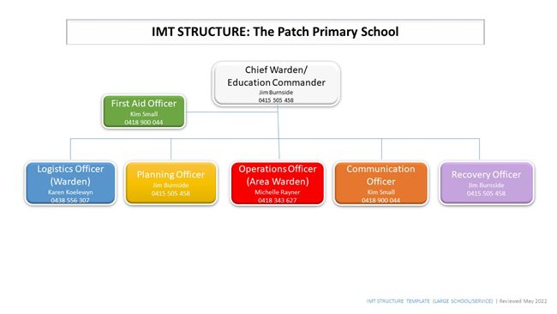

Roles | Primary Contact | Secondary Contact
Chief Warden/Education Commander | Name:  James Burnside  Phone/Mobile:  0415 505 458 | Name:  Michelle Rayner  Phone/Mobile:  0418 343 627
Planning Officer | Name:  Jim Burnside  Phone/Mobile:  0415 505 458 | Name:  Michelle Rayner  Phone/Mobile:  0418 343 627
Operations Officer (Area Warden) | Name:  Michelle Rayner  Phone/Mobile:  0418 343 627 | Name:  Jennie Simpson  Phone/Mobile:  0411 030 172
Communications Officer | Name:  Kim Small  Phone/Mobile:  0418 900 044 | Name:  Alesha Sangster  Phone/Mobile:  0423 030 448
Logistics Officer (Warden) | Name:  Karen Koelewyn  Phone/Mobile:  0438 556 307 | Name:  Kellie McDonald  Phone/Mobile:  0437 699 170
First Aid Officer | Name:  Kim Small  Phone/Mobile:  0418 900 044 | Name:  Deb Allan  Phone/Mobile:  0409 170 751

Incident Management Team Roles & Responsibilities
Core Procedures | Procedure Instructions
Chief Warden/Education Commander | Pre-Emergency  - Maintain current contact details of IMT members.  - Conduct regular exercises/drills.  - Ensure students/staff with special needs list and staff trained in first aid list are up to date.  - Ensure our emergency response procedures are kept up-to-date.  - Ensure staff on the IMT are aware of their responsibilities.  During Emergency  - Attend the emergency control point.  - Ascertain the nature and scope of the emergency.  - Ensure that the emergency services have been notified.  - Ensure the appropriate response has been actioned.  - Convene our IMT as required.  - Initiate evacuation of affected areas/lock-down/lock-out/shelter-in-place as required.  - Brief the incoming emergency services and respond to their requests.  - Report the emergency to ISOC on 1800 126 126  Post- Emergency  - When the incident is rendered safe or the emergency services returns control, notify the IMT members to have staff and students return to normal operations.  - Organise debrief with the IMT and, where appropriate, with any attending emergency Service.  - Compile a report for the IMT and region and notify ISOC (24 hour, 7 days) and the region.
Planning Officer | Pre-Emergency  - Assist the Chief Warden.  - Identify resources required.  - Participate in emergency exercises/drills.  During Emergency  - Attend the emergency control point.  - Ascertain the nature and scope of the emergency.  - Report any changes in the situation to the Chief Warden.  - Act as directed by the Chief Warden.  - Plan for contingencies.  Post- Emergency  - Collect and evaluate information relating to the emergency.  - Identify recovery needs and develop a recovery plan (if required).
Operations Officer (Area Warden) | Pre-Emergency  - Regularly check and report on deficiencies of emergency equipment and kits.  - Coordinate Safety practices (e.g. clear egress paths, access to first attack equipment e.g. fire extinguishers and disposal of rubbish) by wardens throughout their areas.  - Participate in emergency exercises/drills.  During Emergency  On hearing alarm or becoming aware of an emergency, the Operations Warden will:  - Attend the emergency control point.  - Communicate with the Chief Warden by whatever means available and act on instructions.  - Implement the emergency response procedure relevant to the floor or area and ensure that the Chief Warden is notified.  - Direct logistics officer (wardens) to check the floor or area for any abnormal situation.  - Commence evacuation if the circumstances on their floor or area warrant this.  - Control the movement of people.  - Co-opt persons as required to assist a logistics officer (wardens) during an emergency.  - Ensure that any implications for regular bus/student transport arrangements for the school or clients schools are addressed.  - Confirm that the logistics officer’s (warden) activities have been completed and report this to the Chief Warden or a senior officer of the attending emergency services if the Chief Warden is not contactable.  Post Emergency  - Compile report of the actions taken during the emergency for the debrief.
Communications Officer | Pre-Emergency  - Assist the Chief Warden.  - Attend training in the use of the school’s communication system.  - Maintain records and logbooks and make them available for emergency response.  - Ensure emergency and parent contact details are up-to-date.  - Participate in emergency exercises/drills.  - Ensure secondary contact is aware of their role as 'secondary communications officer'  During Emergency  - Attend the emergency control point.  - Ascertain the nature and location of the emergency. Maintain up to date information.  - Confirm that emergency services have been notified.  - Notify appropriate IMT members.  - At the direction of the Chief Warden provide instruction and information to staff, students and parents as required.  - Keep a log of events that occurred during the emergency.  - Act as directed by the Chief Warden.  Post- Emergency  - Collate logs of events completed by all IMT members during the emergency for the debrief and ensure they are secured for future reference.  - Contact parents as required.
Logistics Officer (Warden) | Pre-Emergency  - Ensure staff and students are aware of the emergency response procedures.  - Carry out safety practices (e.g. clear egress paths, access to first attack equipment e.g. fire extinguishers and disposal of rubbish).  - Participate in emergency exercises/drills.  During Emergency  Persons selected to perform as Logistics Warden will carry out activities as set out in the emergency response procedures and as directed by the Operations Warden (Area Warden).  Activities may include the following:  - Attend the emergency control point.  - Operate the communication system in place.  - Check that any fire doors and smoke doors are properly closed  - Close or open other doors in accordance with the emergency response procedures.  - Search the floor or area to ensure all people have evacuated. This function is of greater importance than a later physical count of those evacuated.  - Ensure orderly flow of people into protected area.  - Assist occupants with disabilities.  - Act as lead of groups moving to nominated assembly areas.  - Report status of required activities to the operations officer (area warden) on their completion.  - Act as directed by the Chief Warden.  Post- Emergency  - Compile report of the actions taken during the emergency for the debrief.
First Aid Officer | Pre-Emergency  - Assist the Chief Warden.  - Attend training in the use of the school’s communication system.  - Maintain first aid training as required  - Ensure student medical conditions are accessible in an emergency  - Participate in emergency exercises/drills.  During Emergency  - Collect Emergency Details Folder  - Collect First Aid kit, Emergency Medication, Mobile Phone and student details folders  - Attend the emergency control point.  - Keep a log of Medications provided during the emergency.  - Act as directed by the Chief Warden.  Post- Emergency  - Collate logs of events completed by all IMT members during the emergency for the debrief and ensure they are secured for future reference

Emergency Contacts
During emergency, refer any of the emergency contacts

School Contacts
Key Roles | Name | Phone | Phone (After Hours) | Mobile
Principal | James Burnside | (03) 9756 7463 | 0415 505 458 | 0415 505 458
Assistant Principal | Michelle Rayner | (03) 9756 7463 | (03) 5968 4582 | 0418 343 627
Business Manager | Karen Koelewyn | (03) 9756 7463 | (03) 9756 7830 | 0438 556 307
Office Administrator | Kim Small | (03) 9756 7463 | 0418 900 044 | 0418 900 044
School Council President | Angela Ellis | (03) 9752 0767 | 0412 566 934 | 0412 566 934

DET Contacts
Roles | Name | Phone | Mobile
Regional Director | Karen Money | 1300 333 231
Regional Office (nevr@edumail.vic.gov.au) | General enquiries, Benalla, Glen Waverley | 1300 333 231 (03) 8392 9500
Manager, Operations & Emergency Management | Therese Carroll | 03 8904 2473 | 0448 284 749
Emergency Management Support Officer | Kate Roberts |  | 0427 374 563
Incident Support and Operations Centre (ISOC) |  | 1800 126 126
Programmed Maintenance Services |  | 1300 133 468
OHS Advisory Service |  | 1300 074 715
Employee Assistance Program |  | 1300 361 008
Media Unit (on call 24/7) |  | (03) 8688 7776
SEIL | Denise Kotsikas | (03) 8392 9335
SSSO Team Leader | Julie O'Byrne | (03) 8739 1001 | N/A
Acting SEIL | Scott Crawford | 7505 3671 | 0411 095 592

Local / Other Organizations
Name | Phone
Monbulk Police Station | (03) 9756 6266
Angliss Hospital (Upper Ferntree Gully) | (03) 9764 6111
Gas - Multinet | 132 691
Electricity - SPAusnet | 131 799
Yarra Valley Water | 1300 304 688
Facility Plumber - Greg Paxton | 0408 106 445
Facility Electrician - Steven Young | 0434 525 005
Shire of Yarra Ranges | 1300 368 333
Dept of Health & Human Service (Dandenong) | 1300 555 526
Closest GP - Monbulk Family Clinic | (03) 9752 1455
Facility Maintenance - Glenn Moffitt | 0487 208 532
Kallista - The Patch CFA | 9752 1189

School Bus Emergency Contacts
Bus Routes | Areas Services | Schools serviced or bus coordinating school | Contact Details
Not Applicable

Communication Tree
Communication Tree
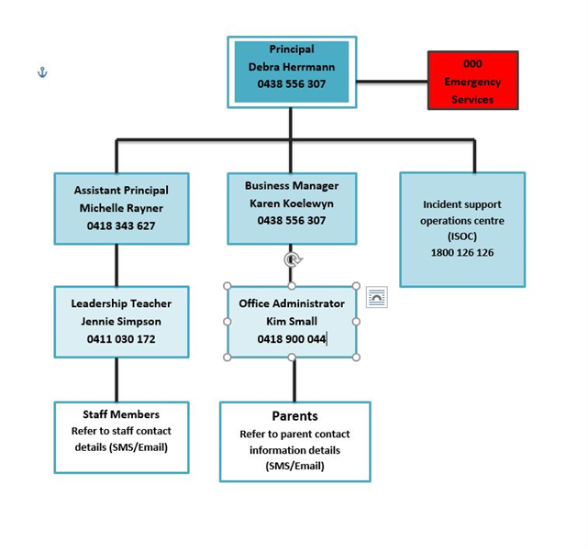

Risk Assessment
Identified Hazards | Description of Risk | Existing Controls | Effectiveness of existing controls | Risk Rating | Controls to be implemented | Revised Risk Rating
Bushfire/Grassfire | Probably Causes: Lightening strike, arson, spark ignitefd by machinery, power line failure, escaped planned burn Probable Consequences: Stress or psychological injury to persons, Fatality and or permanent disability from burns, Serious injury from smoke inhalation. Loss of buildings, facilities and equipment | - As a BARR School, we have a Shelter in Place building with fire preventative measures. E.g: external shutters, water bottles & Fire Hoses.  - Our school will be closed on days of Catastrophic Fire Danger Rating for our area.  - On days of Extreme Fire Danger Rating students will either conduct remote learning from a safe place determined by their family or will re-locate to Knox Central PS in Boronia  - School community (including Kinder and OSHClub) regularly undertake evacuation drills especially in Terms 1 & 4.  - All staff are made aware of their roles annually (usually after review of EMP).  - We have trained fire monitors who are in charge of putting our fire shutters down.  - Fire monitors conduct weekly checks of safety equipment.  - Term OH&S inspections of travel paths to exits and ISOC monitoring of alarms.  - Regular maintenance of grounds, mowing grass and removing ignitable fuels.  - Working bees to clear and clean up school site occue several times per year.  - Local CFA check/test our fire equipment as they feel necessary/required.  - In terms 1 & 4 the fire danger ratings for the week are posted in the daily notice for all staff.  - Restricted play areas for students of days of Severe FDR.  - School communicates relocation and or closure plans for days of elevated fire danger to school community via newsletters, enrolment packs, news feed items and information sessions at the start of the school year and prior to the fire danger period.  - A Watch Zone of 15kms on the VicEmergency App has been established by school staff and is monitored regularly for fires and other incidents. | Acceptable | Consequence  Severe  Likelihood  Possible  Risk Level  Extreme | Triggers for action:  The need for action by the school is triggered when there is a bushfire/grassfire that:  - is observable, or  - identified via Vic Emergency App within 15kms  - ​Permission from Regional Office to relocate on days of Extreme Fire Danger. Relocation plan to Knox Central Primary School in place.  - School will be closed days that are declared a Fire Danger Rating of Catastrophic  - Students to participate in fire safety/awareness sessions with CFA  - Local CFA run regular drills at our school out of school hours to familiarise themselves with our school site.  - Recommended to all staff to have download the Vic Emergency app on their mobile phone with the school as their 'work place' and push notifications on. All admin staff have this and the Office Manager and Principal have the webpage open on their computers screens everyday in Terms 1 & 4.  - Report the incident to ISOC (1800 126 126)  - Monitor conditions such as wind change, size of fire, direction of travel.  - Monitor warnings and advice messages through the Vic Emergency App or website.  - If bushfire or grassfire is in watch zone but does not cover the school site, seek further advice to determine if any action are necessary.  - Vic Emergency Hotline 1800 226 226 and ABC radio are other sources of information.  ADVICE WARNING: Seek advice and monitor conditions as they may change.  WATCH & ACT WARNING: Seek advice and then decide whether to:  -remain on site, shelter in place (if required) and monitor the situation  -call parents to pick up their children  EMERGENCY WARNING: If warning states its too late to leave then shelter in place and seek advice. Advise parents that they should NOT travel to school to pick up their children. If parents do arrive, then advise them to also shelter in place with staff and students.  SHELTER IN PLACE:  - move all students, staff and visitors to the shelter in place.  -Take emergency kit, first aid kit, your EMP and staff,students and visitor attendance lists.  - Check everyone is accounted for.  - Ensure communications with emergency services are maintained.  - Advise parents that school is sheltering in place and NOT to come and pick up children.  - Check all windows, shutters and doors are closed (but doors not locked)  - Staff should attend to students that are known to be susceptible to smoke .  - Communications person to monitor phones to ensure communication is maintained.  - Wait for Emergency Services to arrive or provide further information.  - Any decision to leave the shelter in place should only be actioned on the advice of emergency services.  - Maintain a record of acions/decisions untertaken and times.  Pre-emptive Actions: This school is a category 2 and identified students and staff will relocate to Boronia Central PS on EXTREME FDR days in Melb Northern LGA. (lists attached)  This school will close on CATASROPHIC FDR days.  When relocating the school will use the relactaion checklist: https://www.education.vic.gov.au/PAL/bushfire-preparedness-school-relocation-principal-checklist.docx  When closing the school will use the closure checklist: https://www.education.vic.gov.au/PAL/bushfire-preparedness-school-closure-principal-checklist.docx | Consequence  Major  Likelihood  Possible  Risk Level  High
Structure Fire | - Stress or psychological injury to persons - Fatality and or permanent disability from burns. Serious injury from smoke inhalation. - Loss of buildings, facilities and equipment | - Term OH&S inspections of travel paths to exits and ISOC monitoring of alarms.  - Our school will be closed on days of Catastrophic Fire Danger Rating for our area.  - Communication systems (PA System) is tested on a daily basis.  - School community (including Kinder and OSHClub) regularly undertake evacuation drills especially in Terms 1 & 4.  - All staff are made aware of their roles annually (usually after review of EMP).  - We have trained fire monitors who are in charge of putting our fire shutters down.  - Term OH&S inspections of travel paths to exits and ISOC monitoring of alarms.  - Regular maintenance of grounds, mowing grass and removing ignitable fuels.  - Local CFA check/test our fire equipment as they feel necessary/required.  - Staff training from local CFA on using a fire extinguisher/hoses.  - Annual Test/Tagging of electrical equipment  - As a BARR School, we have a Shelter in Place building with fire preventative measures. E.g: external shutters, water bottles, Fire Hoses and sprinklers on roof. | Acceptable | Consequence  Major  Likelihood  Rare  Risk Level  Medium | - Local CFA run regular drills at our school out of school hours to familiarise themselves with our school site. | Consequence  Major  Likelihood  Unlikely  Risk Level  Medium
Major injury to person in playground | - Significant physical or psychological injury to person. - Psychological injury to witnesses (espesically if Student). | - Adequate amount of staff supervising play areas at break times.  - Staff trained in First Aid and kept current.  - First aid kits maintained regularly. Term first aid kit inspection checklists completed and stock replaced.  - Student medical information kept updated and accessible.  - Area's become 'out of bounds' if deemed not safe to play/risk of causing injury. e.g - Oval out of bounds when really wet to avoid students slipping over or on days of high winds we remove students from oval and restrict play areas to monitor tree's close by. | Acceptable | Consequence  Moderate  Likelihood  Possible  Risk Level  Medium | - Playground equipment maintained/inspected on a regular basis (Term OH&S Inspection completed). | Consequence  Moderate  Likelihood  Unlikely  Risk Level  Medium
Anaphylactic reaction | - Severe allergic reaction possibly leading to death if appropraite action not taken quick enough | - Majority of staff to hold current anaphylaxis competency.  - ASCIAplans and individualstudent anaphylaxis plans are updated annually  - Student medical information constantly updated.  - Two staff member with adrenaline injectors in the yard during breaks, plus a spare in the main office.  - Anaphylactic student details/photo's are visible in staff room, first aid cupboard, Medication Cupboard (Resource Room), CRT folders and Staff Induction folders updated annually.  - 'Nut Free' Policy across the school  - Student EpiPens travel with them from class to class. | Acceptable | Consequence  Major  Likelihood  Unlikely  Risk Level  Medium | - Discourage food sharing between students and educate students around allergic reactions.  - Display anaphylaxis first aid posters prominently around school.  - Anaphylactic students are well aware of their allergens, triggers & symptoms. | Consequence  Severe  Likelihood  Rare  Risk Level  Medium
School Bus crash or breakdown | Probable causes: Bus incident (eg breakdown, fire or flood or other emergency event) or bus accident which occurs: while bus conveying satff and students for camp, excursion or other school activity. Probable consequences: - Physical injury or death to a number of students or staff. - Psychological injury to students or staff, either from crash or witnessing disturbing scenes of others injured. Stress/anxiety to everyone involved. - Traffic disruption/delay/inconvenience | - Engage approved Accredited Bus Operators / Drivers  - Buses hired must have seat belts  - Risk assessment of excursion/camp needs to be completed prior to departing and bus crash/breakdown must be considered with risk controls implemented.  - If bus has broken down in an un-safe position, relocate students to where safest.  - Permission forms for excursions and camps contain parent/guardian emergency contact details. One copy to be kept on site and another to be taken on trip.  - Student Activity Locator (SAL) completed.  - First aid kit to accompany all excursions and first aid qualified staff to attend.  - Traffic management plan to manage school access/egress at drop off / pick up times.  - Supervision to monitor student compliance with school road and bike safety policy.  - All school excursions, camps and off site activities occurring in or requiring transport through determined CATASTOPHIC weather districts will be cancelled. | Acceptable | Consequence  Moderate  Likelihood  Unlikely  Risk Level  Medium | - call 000 to request emergency assistance, if required.  -contact emergency services agencies to ascertain local information on status of any notified emergency.  -Report emergency to the Security Services Unit on 1800 126 126  - Advise emergency services of the status and location of bus services and seek assistance if required.  - Notify your region and seek advice from your Regional Manager, Operations and Emergency Management if required.  - Confirm/provide instructions to driver with regard to destination.  -notify parents/guardians of all affected students of actions taken and other relevant information (such as where to collect their children)  - Keep an accurate log of all communication in relation to the event.  - Receive confirmation of buses arrival at destination from driver and/or supervising staff  -Direct all media enquiries to DET Media Unit on 8688 7776
Bomb/substance threat | Probable Causes: Known or unknown person with intent or harm or cause fear to staff and students of the school; Prank Probable Consequences: Physical injury to staff, visitors, contractors or students; Stress or psychological injury requiring clinical support for multiple individuals | - School community regularly schedule and undertake evacuation drills  - Reception phone has a 'Telephone Bomb Threat Checklist' next to it - instructions on what to say and ask.  - Along with the 'Telephone Bomb Threat Checklist' there is a sign the person on the phone can hold up to someone else stating that they're receiving a bomb threat and to call the police. | Acceptable | Consequence  Major  Likelihood  Rare  Risk Level  Medium
Gas leak | - Physical harm or even death of staff, visitors or students. - post psychological problems requiring medical assistance/support. - Damage to school property, loss of buildings, facilities and equipment due to fire/explosion. | - School community regularly undertake evacuation drills to off-site evacuation point.  - Annual servicing of appliances  - evacuation maps in each building/classroom along with brief description of alarm codes. | Acceptable | Consequence  Major  Likelihood  Rare  Risk Level  Medium
Boiler room explosion | - Physical harm to persons or even death if close to the explosion - Pychological injury to students or staff, either from situation or witnessing disturbing scenes of others injured. - stress/anxiety to everyone involved. - Damage to school property and buildings. | - School community regularly undertake evacuation drills to our off-site evacuation point and aware of our emergency management procedure.  - Annual servicing of boiler | Acceptable | Consequence  Major  Likelihood  Unlikely  Risk Level  Medium
Local plastics factory explosion | - Physical harm to persons from smoke inhalation containing harmfull chemicals. | - School community regularly undertake evacuation drills to shelter in place & off-site evacuation point.  - Recommended to all staff to have download the Vic Emergency app on their mobile phone with the school as their 'work place' and push notifications on. All admin staff have this and the Office Manager and Principal have the webpage open on their computers screens everyday in Terms 1 & 4.  - Cancel all outside activities planned for the day. | Acceptable | Consequence  Major  Likelihood  Rare  Risk Level  Medium
Severe weather event | Probable Causes: Weather pattern Probable Consequences: Physical injury to staff or students; Stress or psychological injury requiring clinical support for multiple individuals; Electrical storm causing fire; High winds causing roof to collapse, limbs to fall from trees and airborne debris shattering windows; Rain inundation resulting in unsafe electrical wiring/loss of power and communications. | - School liaises with SES/local government to identify potential local risks.  - School has a contingency for storage in our 'shelter in place' building of equipment/materials if necessary.  - On the basis of weather forecast, weather monitors are required to secure loose objects in open areas e.g. garbage bins, seats, sports equipment  - Communications are tested quarterly.  - Utility shut-off instructions/points are known.  - Back up communications and contact lists frequently updated in case power fails.  - Condition of large trees regularly checked.  - students in restricted play area away from large tree's in break time or inside if there is lightening or thunder.  - Registered with 'VicEmergency' on admin staff emails and App on mobiles/ipads to receive severe weather alerts.  - Prior to a storm refer to our Pre, during and post 'Severe Weather Event' process' in our Emergency Management Plan  - We have a regular maintenance schedule of inspecting and clearing gutters/drains | Acceptable | Consequence  Moderate  Likelihood  Possible  Risk Level  Medium | - If severe weather event results in loss of power we have a generator available to run the Hall/SIP. Generator to eventually be connected to main school building as well. | Consequence  Moderate  Likelihood  Possible  Risk Level  Medium
Influenza pandemic | Probable causes: contagious illness; Influenza virus; Vulnerability to infection Probable consequences: Spread of illness; High absenteeism | - Sick and ill students and staff discouraged from being at school  - Regular risk infection procedures outlined at staff meetings by DET health website  - Parents/carers informed of school policy regarding sick children in newsletter  - Enact our EMP  - Notify DHHS of confirmed case and seek advice  - Implement response to community advising information after receiving appropriate advice from DET.  - reinforce appropriate hygiene measures to staff and students.  - Provide convenient access to water, soap and alcohol based hand sanitiser.  - dispose of tissues and hand paper towel appropriately. | Acceptable | Consequence  Moderate  Likelihood  Unlikely  Risk Level  Medium
Smoke | Probable Causes: Fire at nearby factory/premises; Road accident involving a vehicle transporting a hazardous substance; bushfire/grassfire; planned burning. Being situated in a forest, we experience a lot planned burn smoke. Probable Consequences: Physical injury to staff or students; Stress or psychological injury requiring clinical support for multiple individuals | - Medical treatment plans for children with pre-existing heart or lung conditions are current and accessible in the medication cupboard  - Flowchart to dealing with an Asthma attack poster on front of first aid cupboard and medication cupboard.  - Medication is kept accessible  - Air conditioners allow recirculation of air  - Watch Zone on VicEmergency App  - We take precautionary health advice on smoky days – i.e. limit outside activity, yard duty staff carry school spare ventolin, limit physical activity and consider rescheduling outdoor events  - Appropriate first aid kit's kept up to date and inspected each term  - For severe smoke, relocation to shelter in place and shutters down to reduce smoke inhalation.  - Student medical files regularly updated containing asthma student details. | Acceptable | Consequence  Moderate  Likelihood  Possible  Risk Level  Medium
Loss of essential services | Probable Causes: Issue with supply due to storm/accident; Planned outage Probable Consequences: Lack of availability of school resources such as computers; Lack of availability of fresh drinking water and water for flushing toilets | - The size and health of trees growing close to power lines are regularly checked and pruned or removed if necessary - annual tree audit  - Divert school number to school mobile phone.  - Alternate lighting sources, such as a torch or battery operated light are contained in the emergency kit  - A list of emergency phone numbers is located next to all office phones  - Business continuity plan  - Notify/Liaise with the Regional Office and formulate notification to community that the school cannot operate if there is no Fresh water or flushing toilets or whatever the hazard is.  - ISOC notified immediately on 1800 126 126 | Acceptable | Consequence  Minor  Likelihood  Possible  Risk Level  Medium | - generator available to get power to the Hall / SIP. Will eventually be connected to the main school building
Child Abuse | Probable causes: Domestic violence; Substance abuse; Stress/isolation; Mental health problems/intellectual disability; Lack of parenting skills Probable consequences: Physical and psychological trauma/distress/injury; Depression/apathy; Inability to concentrate; Emotional/behavioural/learning problems; Eating Disorder | - Recognise indicators of Child Abuse  - We meet Child Safe Standards  - All visitors are to read, accept and sign our child safety code of conduct.  - PROTECT protocol  - Student Critical Incident Advisory Line  - Student Support Services/Student Welfare Coordinator  - disclosures or noticings managed by Karen R. All records kept on file. | Acceptable | Consequence  Minor  Likelihood  Likely  Risk Level  Medium
Information Security | Probable Causes: Hacking; Malware virus; Unprotected systems/passwords; Accidental Probable consequences: Inconvenience Inability to access/use computer system; Loss/corruption of files/data; privacy breach | - Privacy (including DET’s Schools’ Privacy Policy)  - Privacy, Department provided software  - Privacy (requests for Information about Students)  - Acceptable use of ICT Resources  - Staff member manages and reviews school’s privacy practices  - Regular privacy audit by I.T coordinator to determine what information the school collects, how it is used and with whom information is shared.  - Examine data security arrangements  - BYOD usage and guidelines are followed  - Password protocols for ICT | Acceptable | Consequence  Minor  Likelihood  Unlikely  Risk Level  Low
Medical Emergency | Probable causes: Accident/misadventure; known/unknown illness Probable consequences: Ill health, recuperation; hospitalization; impact on continuity of education; Psychological distress for those witnessing incident | - Staff trained in first aid  - First Aid Kit  - Staff observant to signs of illness  - Medical history – staff/students  - First Aid and Infection Control Procedure  - Medication Authority Form and authority to administer  - Employee Assistance Program (EAP) available to staff and family members | Acceptable | Consequence  Major  Likelihood  Unlikely  Risk Level  Medium
Mental Stress | Probable causes: Exposure to distressing event; Anxiety/depression; illness Probable consequences: Psychological trauma/distress; Attempted suicide; Suicidal ideation/self-harm; Interrupted learning | - Student Support Services  - Well-being staff in school (Alesha)  - SafeMinds  - Navigator Program  - Student Engagement and Inclusion Guidance  - Building Resilience Framework  - Victorian Anti-bullying and Mental Heath Initiative  - all staff are made aware of the Employee Assistance Program and a poster is displayed on the staff notice board  - We have student Kindness Matters monitors to support other students in the school.  - Principal/Managers aware and mindful of workload on staff. | Acceptable | Consequence  Minor  Likelihood  Possible  Risk Level  Medium
Missing person - school or school camp/excursion | Probable causes; Lost or separated whilst on camp/excursion; Truancy; Unknown - i.e. distress Probable consequences: injury; interrupted education; psychological trauma/distress | - School records attendance  - Unexplained absence notification is sent out at 9:30am each morning.  - Student engagement policy to promote school attendance and address truancy, which is staged  - Recess and lunchtime supervision.  - Behaviour Support Plans to address individual truancy - Individual learning plan.  - Student Activity Locator to be completed ahead of all camps/excursions (which includes outlining all students to attend camp)  - List of students to attend camp/excursion to be held at school site and by Teacher in Charge on camp.  - School excursion/camp risk assessment completed prior to confirming booking.  - Adequate ratio of staff/parent helpers on yard duty and excursions/camps. | Acceptable | Consequence  Minor  Likelihood  Unlikely  Risk Level  Low | - students identified as flight risks are monitored by teachers and ES staff.
Traumatic Death/Injury/Grief | Probable causes: Accident/misadventure; Existing illness; Sudden medical emergency Probable Consequences: Distress/anger; Disruption to school operations; Disruption to school operations; Stress, psychological injury, impact on well-being requiring support | - Student Support Services  - Well-being staff in school (Alesha)  - Managing Trauma Guide  - Incident Support and Operations Centre referrals  - Employee Assistance Program | Acceptable | Consequence  Minor  Likelihood  Possible  Risk Level  Medium
Violence, Aggression and/or harassment | Probable causes: underlying abuse or exposure to family violence; developmental factors Probable Consequences: physical or psychological harm; Disruption to learning/continuity of education | Site based policies and strategies  - Adequate number of staff supervising Lunchtime and recess.  - School based security measures e.g. duress alarm, CCTV  - Behavioural Code of Conduct  - School social media strategies to address online harassment  - Requirement for multiple staff to be present at meetings or incidents involving aggressive parent or student  School pursues specific interventions or referrals as required/appropriate:  - Trespass order  - Child Protection referral  - Family violence referral  Specific supports for students with challenging behaviors and interventions:  - Referral to Student Support Services (SSS)  - School Wide Positive Behaviour Support strategies (Behaviour Support Plans etc.)  - Restraint and Seclusion procedures  - Respectful Relationships  - Health and Human Services Behaviour Support Services  - More advanced supports accessed as appropriate e.g. Engagement of a Student Support Services visiting professional  - School welfare officer/coordinator engaged  Training  - Diffusion strategies and training for staff  - Conflict management training  - Awareness training and resources – Building Resilience and Preventing Radicalisation to Violent Extremism  Specific support for teacher/staff in dealing with challenging behaviours  - Employee Assistance Program (EAP) for impacted staff  - Principal Mentor Program  - Proactive Wellbeing Supervision  - Early Intervention Principal Support Service  Refer to additional resources for impacted persons  - School wide Positive Behaviour Support  - Koori inclusive School Wide Positive Behaviour Support and individual plans in place | Acceptable | Consequence  Moderate  Likelihood  Possible  Risk Level  Medium
Intruder | Probable Causes: Substance abuse/drug affected; Mental health issues;Custodial/Parent dispute; Political views; Police operation Probable Consequences: Physical injury to staff or students; Stress or psychological injury requiring clinical support for multiple individuals | - Visitor sign-in procedure recognised across school community  - Lanyards or printed label provided to all visitors/Contractors signed in at the school.  - remove persons in the immediate vicinity to avoid them being exposed to physical/psychological abuse.  - Students always move around school in pairs during class time  - Lock down emergency drill is practised annually so students are aware of lock down procedure.  - Staff share 'need to know' information to other staff concerning parent or student issues.  - staff yard duty roster in place with ample staff  - All staff, especially Yard duty staff are confident to approach anyone out of 'the normal'.  - Parents must make an appointment to meet with teachers/principal.  - Values of mutual respect and acceptable parent behaviour policy are communicated and regularly reinforced e.g. at parent forums and in newsletters.  - Encourage engagement of parents in school activities.  - In relation to court orders / custody  - the school maintains a register of current documents/concerns  - parents are advised of the relevant school processes and duty of care to other students and staff.  - For parent meetings where staff feel a need for support:  - two staff attend  - staff use a signal to obtain support from another staff member if required  - an appropriate room for meeting selected e.g. one with two exit points | Acceptable | Consequence  Moderate  Likelihood  Possible  Risk Level  Medium
Snakes | Probable Causes: Warm, dry temperatures; Proximity of bushland/grassland to school Probable Consequences: Physical injury to staff or students; Stress or psychological injury requiring clinical support for multiple individuals | - School grounds are cleared of all refuse and grass is cut regularly  - Staff with first aid qualifications are trained in responding to a snake bite  - Staff wear protective footwear on yard duty  - Food in the chicken coup/shed is kept in tight sealed containers to reduce vermin  - Phone number of snake handler is on display on first aid cupboard and medication cupboard. | Acceptable | Consequence  Major  Likelihood  Possible  Risk Level  High | - School has educated students on snake awareness, not to approach them and notify the teacher on duty. Especially in the warmer months.  - High snake risk areas such as the wetlands and the tree line of the forest is an all year round 'out of bounds' for students. | Consequence  Major  Likelihood  Unlikely  Risk Level  Medium
Coronavirus outbreak/pandemic | Probable causes: contagious illness; virus; Vulnerability to infection. Probable consequences: Spread of illness resulting in high absenteeism and school closure for deep cleaning. | - social distancing between adults and staff.  - Recommendations regarding the use of face masks to be followed  - following guidance from the Chief Health Officer.  - Cooperate with DHHS in outbreak investigation and management  - Cancelling/postponing excursions/camps.  - Ensuring our community understands and are following exclusion and social distancing  - Ensure the provision of necessary hygiene supplies  - Visitors / Staff to utilise QR Code sign in for government contract tracing purposes when on site.  - Air purifiers being used in all classrooms | Acceptable | Consequence  Moderate  Likelihood  Possible  Risk Level  Medium
COVID-19 | Probable Causes: Contagious illness. Probable consequences: Spread of illness; High absenteeism, school closures | Existing controls are detailed within the following documents:  DET School Operations Guide  https://edugate.eduweb.vic.gov.au/sites/i/Pages/production.aspx#/app/content/3336/  Health and Safety Advice for Schools in the context of Coronavirus (COVID-19) developed by Victoria’s Chief Health Officer (https://edugate.eduweb.vic.gov.au/sites/i/Shared%20Documents/Coronavirus/School%20Operations%20Guide/health-advice-term-4.docx). | Acceptable | Consequence  Severe  Likelihood  Likely  Risk Level  Extreme | The Principal will monitor the regular COVID updates provided to schools to ensure any revised controls are implemented at the school level. | Consequence  Major  Likelihood  Possible  Risk Level  High
Mosquito-borne diseases | Probable Causes: Warm and wet weather conditions, periods of heavy rainfall or flooding, stagnant water. The peak period for mosquitoes is from October to March. Probable Consequences: Mosquito bites can cause discomfort and allergic reactions. Mosquito-borne diseases can make people ill and, in severe cases, can cause death. | - Conducting regular inspections of school grounds to check for stagnant water or unsealed water sources  - Encouraging all students and staff to use insect repellent containing picaridin or DEET on exposed skin on days where mosquitoes are observed  - Encouraging long, loose-fitting clothing outdoors when mosquitoes are observed | Effective | Consequence  Moderate  Likelihood  Unlikely  Risk Level  Medium | During periods when a high level of mosquito activity is observed:  - Close windows and doors without flyscreens and consider alternative ventilation options.  - Limit or reschedule outdoor activity, particularly when planning camps and other outdoor activities.  - make insect repellent containing picaridin or DEET readily available to staff and students  - Encourage all students and staff to both use insect repellent and wear long, loose fitting clothing if outdoors. | Consequence  Moderate  Likelihood  Unlikely  Risk Level  Medium

Core Emergency Response Procedures
Core Procedures | Procedure Instructions
On-site evacuation/relocation procedure | When it is unsafe for students, staff and visitors to remain inside the school building the Chief Warden on-site will take charge and activate the Incident Management Team if necessary.  - Call 000 for emergency services and seek and follow advice.  - Evacuate students, staff and visitors to the Hall or to the Oval (depending on location and nature of emergency).  - Report the emergency and evacuation to Incident Support and Operations Centre (24 hour, 7 days) on 1800 126 126  - Take your emergency kit/first aid kit (including your student and staff attendance lists and a copy of this EMP).  - Once at your primary and/or secondary assembly point/s, check all students, staff and visitors are accounted for.  - Ensure communications with emergency services is maintained.  - Wait for emergency services to arrive or provide further information.  - Notify your region and seek advice from your Regional Manager, Operations and Emergency Management if required.  - Confirm with emergency service personnel that it is safe to return to normal operations.  - Maintain a record of actions/decisions undertaken and times.  - Contact parents as required.  - generator available for power to the SIP (hall) should it be needed  - Satellite phone available in the Emergency trolley if there is no reception (may need to stand near an open window or just outside to get reception)  Actions after on-site evacuation/relocation procedure  - Ensure any students, staff or visitors with medical or other needs are supported.  - Advise the Incident Support and Operations Centre and the region (Regional Manager, Operations and Emergency Management) that the evacuation is over.  - Determine whether to activate your parent re-unification process.  - Determine if there is any specific information students, staff and visitors need to know (for example, parent reunification process or areas of the facility to avoid).  - Print and issue pre-prepared parent letters and give these to students to take home.  - Ensure all staff are made aware of Employee Assistance Program contact details.  - Seek support from your region/regional Manager, Operations and Emergency Management if required.  - Undertake operational debrief with staff and Incident Management Team to identify any on-site evacuation and procedural changes that may be required.  - Complete your Post Emergency Record.
Off-site evacuation procedure | If it is unsafe for students, staff and visitors to remain on the school grounds the Chief Warden on-site will take charge and activate the Incident Management Team if necessary.  - Call 000 for emergency services and seek and follow advice.  - Identify which off-site assembly point you will evacuate staff, students and visitors to.  - Evacuate staff, students and visitors to the Oval.  - Report the emergency and evacuation to Incident Support and Operations Centre (24 hour, 7 days) on 1800 126 126.  - Take your emergency kit/first aid kit (including your student and staff attendance lists and a copy of this EMP).  - Once at primary and/or secondary assembly point/s, check all students, staff and visitors are accounted for.  - Ensure communications with emergency services is maintained.  - Wait for emergency services to arrive or provide further information.  - Notify your region and seek advice from your Regional Manager, Operations and Emergency Management if required.  - Confirm with Emergency Service personnel that it is safe to return to normal operations.  - Maintain a record of actions/decisions undertaken and times.  - Contact parents as required.  Actions after off-site evacuation procedure  - Ensure any students, staff or visitors with medical or other needs are supported.  - Advise the Incident Support and Operations Centre and the region (regional Manager, Operations and Emergency Management) that the evacuation is over.  - Determine whether to activate your parent re-unification process.  - Determine if there is any specific information students, staff and visitors need to know (for example, parent reunification process or areas of the facility to avoid).  - Direct all Media enquiries to DET Media Unit on 8688 7776.  - Contact the SSSO Network Coordinator if required.  - Print and issue pre-prepared parent letters and give these to students to take home.  - Ensure all staff are made aware of Employee Assistance Program contact details.  - Seek support from your region/Regional Manager, Operations and Emergency Management if required.  - Undertake operational debrief with staff and Incident Management Team to identify any off-site and procedural changes that may be required.  - Complete your Post Emergency Record.
Lock-down procedure | When an external and immediate danger is identified and it is determined that the students should be secured inside the building for their own safety the Chief Warden on-site will take charge and activate the Incident Management Team if necessary.  - Call 000 for emergency services and seek and follow advice.  - Initiate the lock-down (code black) and provide instructions to staff, for example, close internal doors and windows, remain in classroom, sit below window level or move into corridors.  - Check that all external doors (and windows if appropriate) are locked.  - If available, allocate staff to be posted at locked doors to allow students, staff and visitors to enter if locked out.  - Report the emergency and lock-down to the Incident Support and Operations Centre (24 hour, 7 days) on 1800 126 126.  - Divert parents and returning groups from the school if required.  - Ensure a telephone line is kept free.  - Keep public address system free.  - Keep main entrance as the only entry point. It must be constantly monitored and no unauthorised people allowed access.  - If safe to do so, have a staff member wait at the main entry to the school to guide emergency services personnel.  - As appropriate, ascertain that all students, staff and visitors are accounted for.  - Notify your region and seek advice from your Regional Manager, Operations and Emergency Management if required.  - As appropriate, confirm with emergency services personnel that it is safe to return to normal operations.  - Maintain a record of actions/decisions undertaken and times.  - Contact parents as required.  Actions after lock-down procedure  - Ensure any students, staff or visitors with medical or other needs are supported.  - Advise the Incident Support and Operations Centre and the region (Regional Manager, Operations and Emergency Management) that the lock-down is over.  - Determine whether to activate your parent re-unification process.  - Determine if there is any specific information students, staff and visitors need to know (for example, parent reunification process or areas of the facility to avoid).  - Direct all Media enquiries to DET Media Unit on 8688 7776  - Print and issue pre-prepared parent letters and give these to students to take home.  - Contact the SSSO Network Coordinator if required.  - Ensure all staff are made aware of Employee Assistance Program contact details.  - Seek support from your region/Regional Manager, Operations and Emergency Management if required.  - Undertake operational debrief with staff and Incident Management Team to identify any lock-down and procedural changes that may be required.  - Complete your Post Emergency Record.
Lock-out procedure | When an internal immediate danger is identified and it is determined that students should be excluded from buildings for their safety the Chief Warden on-site will take charge and activate the Incident Management Team if necessary.  - Call 000 for emergency services and seek and follow advice.  - Announce lock-out with instructions about what is required. Instructions may include nominating staff to:  - Lock doors to prevent entry  - Check the premises for anyone left inside  - Obtain Emergency Kit  - Go to the designated assembly point/s, either the Hall or Oval, depending on the site of the emergency.  - Check that students, staff and visitors are all accounted for.  - Report the emergency and lock-out to the Incident Support and Operations Centre (24 hour, 7 days) on 1800 126 126.  - Notify your region and seek advice from your Regional Manager, Operations and Emergency Management if required.  - Where appropriate, confirm with emergency services personnel that it is safe to return to normal operations.  - Maintain a record of actions/decisions undertaken and times.  - Contact parents as required.  Actions after lock-out procedure  - Ensure any students, staff or visitors with medical or other needs are supported.  - Advise the Incident Support and Operations Centre and the region (regional Manager, Operations and Emergency Management) that the lock-out is over.  - Determine whether to activate your parent re-unification process.  - Determine if there is any specific information students, staff and visitors need to know (for example, parent reunification process or areas of the facility to avoid).  - Print and issue pre-prepared parent letters and give these to students to take home.  - Direct all Media enquiries to DET Media Unit on 8688 7776.  - Ensure all staff are made aware of Employee Assistance Program contact details.  - Contact the SSSO Network Coordinator if required.  - Seek support from your region/Regional Manager, Operations and Emergency Management as required.  - Undertake operational debrief with staff and Incident Management Team to identify any lock-out and procedural changes that may be required.  - Complete your Post Emergency Record.
Shelter-in-place procedure | When an incident occurs outside the school and emergency services or the Chief Warden determines the safest course of action is to keep students and staff inside a designated building in the school (as evacuation might reasonably expose people to a greater level of danger until the external event is handled), the Chief Warden on-site will take charge and activate the Incident Management Team if necessary.  - Call 000 for emergency services and seek and follow advice.  - Chief Warden activates the Incident Management Team.  - Move all students, staff and visitors to the pre-determined shelter-in-place area, the Hall.  - Take your emergency kit/first aid kit (including your student and staff attendance lists and a copy of this EMP).  - Report the emergency to the Incident Support and Operations Centre (24 hour, 7 days) on 1800 126 126.  - Check that all students, staff and visitors are accounted for.  - Ensure communications with emergency services is maintained.  - Wait for emergency services to arrive or provide further information.  - Notify your region and seek advice from your Regional Manager, Operations and Emergency Management if required.  - Where appropriate, confirm with emergency service personnel that it is safe to return to normal operations.  - Maintain a record of actions/decisions undertaken and times.  - Contact parents as required.  - Generator available for power to SIP (Hall) should you need it  - Satellite phone available in emergency trolley if no reception available. (will need to stand near open window or just outside to get service)  Actions after shelter-in-place procedure  - Ensure any students, staff or visitors with medical or other needs are supported.  - Advise the Incident Support and Operations Centre that shelter-in- place is over.  - Determine whether to activate your parent re-unification process.  - Determine if there is any specific information students, staff and visitors need to know (for example parent reunification process or areas of the facility to avoid).  - Direct all Media enquiries to DET Media Unit on 8688 7776.  - Print and issue pre-prepared parent letters and give these to students to take home.  - Ensure all staff are made aware of Employee Assistance Program contact details.  - Contact the SSSO Network Coordinator if required.  - Seek support from your region/Regional Manager, Operations and Emergency Management as required.  - Undertake operational debrief with staff and Incident Management Team to identify any shelter-in-place and procedural changes that may be required.  - Complete your Post Emergency Record.

Specific Emergency Response Procedures
Specific Procedures | Procedure Instructions
Bushfire/Grassfire | - Bushfire/Grassfire Specific Emergency Response Procedures.  Triggers for Action.  The need for action by the school is triggered when there is a bushfire or grassfire that;  - is observable, or  - identified via Vic Emergency App within (insert your pre-determined watch zone) km from the school.  - there is an Advice, Watch and Act, Emergency Warning or Evacuation message that includes your School.  Immediate Actions / Seek Advice .  - If immediate emergency services assistance is required phone '000'.  - Seek advice from your regional Manager, Operations and Emergency Management, regional Emergency Management Support Officer, or regional IMT (if activated). They can gain additional information and advice from emergency services for you.  Name Role Mobile number  Insert name Manager Operations and Emergency Management Insert Number  Insert name Emergency Management Support Officer Insert Number  - Report the incident to ISOC (1800 126 126)  - Convene your Incident Management Team (IMT)  - Continue to monitor conditions such as wind change, size of fire, direction of travel.  - Continue to monitor warnings and advice messages through the VicEmergency App or website.  - If there is a bushfire or grassfire in your watch zone with an associated warning area that does not cover the school site, seek further advice to determine if any actions are necessary.  Other sources of Information  - Vic Emergency Hotline on 1800 226 226 for any information on the incidents and warnings in your area.  - ABC local radio – use a battery powered radio if necessary due to the possibility of power outages.  Actions for the School when it is within a VicEmergency warning area  VicEmergency Warning What it means School Actions  Advice Warning Issued to notify the community that an incident/event has occurred that may escalate to impact on life or property. Actions may be recommended for preparedness or vulnerable groups. If your school is in an Advice Warning area, then seek advice and monitor conditions as they may change.  Watch and Act Warning Issued when an incident/event is likely to or is directly impacting the community. They need to take action now. If your school is in a Watch and Act Warning area, seek advice and then decide whether to; - remain on site, shelter in place (if required) and monitor the situation - call parents to pick up their children - evacuate the school to your offsite bushfire evacuation location.  Emergency Warning Issued when the community is in imminent danger of an incident/event and need to take action now. If your school is in an Emergency Warning area and the warning states that it is too late to leave, then shelter in place and seek advice. Advise parents that they should not travel at the school to pick up their children. If parents do arrive, then advise them to also shelter in place with staff and students at the school.  Prepare to Evacuate Prepare to Evacuate – Issued when it is recommended to that the community should quickly prepare to leave the area. This may include undertaking actions to prepare their family, gather critical items and protect their property. If your school is in an Evacuation area;comply with evacuation instructions provided and seek advice.  Evacuate Now Evacuate Now – Issued when the community is recommended to immediately leave or processes are in place to evacuate communities. If your school is in an Evacuation area;comply with evacuation instructions provided and seek advice..  Sheltering in Place.  If sheltering-in-place is required, move all students, staff and visitors to the Shelter in Place if possible, provided it is safe to do so.  - Take your emergency kit, a first aid kit, your EMP and student and staff attendance lists.  - Check fire equipment including; torches, water, batteries, radio, water, mops, buckets, school portable phone, P2 smoke masks, personal protective equipment and mobile phone are in the Shelter in Place.  - Check that all students, staff and visitors are accounted for.  - Ensure communications with emergency services are maintained.  - Advise parents that the school is sheltering in place and they should not come to pick their children up.  - If parents arrive, encourage them to stay with their children at the school.  - Check all windows and doors in the Shelter in Place are closed (but doors are not locked).  - Turn off gas supply  - Any sprinkler system around the school grounds to be turned on (if this does not compromise other water-based defence systems).  - If safe to do so, relocate cars and any other movable combustible objects to greater than 20m from the Shelter in Place and the evacuation path between the Shelter in Place and Onsite Bushfire Evacuation location and Offsite Bushfire Evacuation Location.  - Staff should attend to students who show signs of or are known to be susceptible to smoke. If possible, supply these students with P2 smoke masks and any medication they require.  - The Communications Officer or a nominated person is to monitor the phones and/or radios to ensure that communication is maintained.  - Wait for emergency services to arrive or provide further information.  - Any decision to leave the Shelter in Place should only occur on advice of emergency services  - Continually monitor Shelter in Place for embers or building ignitions and immediately put them out, when safe to do so. Staff, where possible, should wear full length, fire resistant natural fibre clothing (e.g. wool or cotton) and other personal protective equipment including; goggles, leather gloves and P2 smoke masks, for patrolling the Shelter in Place for embers and building ignitions.  - If the building has ignited and is not safe to extinguish – evacuate to the > Shelter in Place.  - Maintain a record of actions/decisions undertaken and times.  As appropriate insert any additional mitigation steps relevant to your facility that you have identified in your risk assessment.  Generator available to SIP (hall) should power not be avilable.  Satellite phone available in the emergency trolley should all phone reception be lost.
Structure Fire | Call 000 for emergency services and seek and follow advice.  - Activate the fire alarm.  - If appropriate, follow the procedure for on-site evacuation.  - Report the emergency immediately to the Chief Warden who will convene your IMT if necessary.  - Extinguish the fire (only if safe to do so).  - Evacuate to the shelter-in-place closing all doors and windows.  - Check that all areas have been cleared and notify the Chief Warden.  - Check that all students, staff, visitors and contractors are accounted for.  - Report emergency to the Incident Support and Operations Centre (24 hour, 7 days) on 1800 126 126  - Notify your region and seek advice from your regional Manager, Operations and Emergency Management if required.  - Contact parents as required.  - Direct all Media enquiries to DET Media Unit on 9637 2871.
Major injury to person in playground | - call 000 immediately via mobile that can be used to remain with injured person, and provide first aid as required  - at least two staff remembers to remain with the injured person, while other staff members begin removing other persons from the immediate area.  - contact emergency contact/s  - office staff to print out medical conditions report for that person and hand to paramedics (if applicable)  - notify Incident Support and Operations Centre (24 hour, 7 days) of injury 1800 126 126 and follow any necessary advice  - Log Edusafe Plus or CASES21 incident - depending if injury to student or staff member  - Notify Work safe on 132 360 to obtain a reference number.  - the Work Safe incident notification form needs to be completed within 48 hours.
Anaphylactic reaction | Follow the instructions as per the ASCIA Action Plan for Anaphylaxis which include:  - Lay person down flat  - Send another staff member to locate persons adrenaline autoinjector and the students specific ASCIA Action Plan for Anaphylaxis  - Call 000 immediately for an ambulance  - Administer adrenaline autoinjector  - note down the time of administration and place autoinjector back in cover.  - send for school back-up autoinjector located in the Resource Room  - Contact emergency contact  - Hand used Adrenaline autoinjector to paramedics upon arrival  - All people involved to debrief with first aid officer and/or workplace manager to complete post anaphylacticincidentreport.
School Bus crash or breakdown | Use this procedure for an emergency that arises involving a government school bus on route.  The Principal/Teacher in charge will:  - Contact emergency services agencies to ascertain local information on status of any notified emergency.  - Report emergency to Incident Support and Operations Centre (24 hour, 7 days) on 1800 126 126  - Advise emergency services of the status and location of bus services and seek assistance if required.  - Notify your region and seek advice from your regional Manager, Operations and Emergency Management if required.  - Confirm/provide instruction to driver with regard to destination.  - Consult to ensure and notify parents/guardians of all affected students of actions taken and other relevant information (such as where to collect their children).  - Keep an accurate log of all communication in relation to the event.  - Receive confirmation of bus’s arrival at destination from driver.  - Direct all Media enquiries to DEECD Media Unit on 8688 7776.
Bomb/substance threat | If a suspicious object is found (or the threat identifies the location of a bomb)  Immediate response  - Immediately clear and cordon off the area in the vicinity of the object.  - Call 000 for police and seek and follow advice.  - Report the threat to the Chief Warden/principal who will coordinate the emergency response until police arrive.  - Report the emergency to Incident Support and Operations Centre (24 hour, 7 days) on 1800 126 126  - Do not approach, touch, tilt or tamper with the object.  Evacuation  - Evacuate the school to the appropriate relocation point, ensuring students and staff are not directed past the isolated area  - Alert any other services located at the school  - Check all students, staff and visitors are accounted for  Communication  - Provide police with details of the situation, including actions taken so far or intending to take.  - Follow advice provided from Police  - Notify Emergency Management on any new information/update on situation 1800 126 126 (ISOC)  - Direct all Media enquiries to DET Media Unit on 8688 7776  If a bomb/substance threat received via phone  - DO NOT HANG UP  - Keep the person talking for as long as possible and try obtain as much information as possible  - Without alerting the caller, get a co-workers attention and hold up sign by the phone saying 'bomb threat, call 000 immediately'  - Co-worker to call 000 and notify Principal or staff member in charge on particular day  - Begin filling out and asking questions on the 'bomb threat checklist' located next to receptions phone.  Once the call is finished  - DO NOT HANG UP THE PHONE  - it may be possible for police to trace the call if the phone line is kept open, regardless if the caller hangs up.  - Immediately inform Principal (if this hasn't been done yet)  - Provide bomb threat checklist to police upon arrival  If a bomb/substance threat is received via email or letter  - DO NOT DELETE OR THROW OUT THE MESSAGE  - if it is a letter, place in clear sleeve and store in secure place  - avoid any further contact with the letter  - call 000 police  - notify Principal  - Activate evacuation and communication plan as applicable
Severe weather event | - Call 000 if emergency services are needed and seek and follow advice.  - Before the storm, store or secure loose items external to the building, such as outdoor furniture and rubbish bins.  - Secure windows (close curtains and blinds) and external doors. If necessary, tape windows and glass entrances. Utilise boards and sandbags if required.  - During a severe storm:  - Remain in the building and keep away from windows.  - Restrict the use of telephone landlines to emergency calls only, particularly during a thunderstorm.  - Report any matter concerning the safety and wellbeing of students, staff and visitors to the Chief Warden.  - Disconnect electrical equipment - cover and/or move this equipment away from windows.  - Report emergency to Incident Support and Operations Centre (24 hour, 7 days) on 1800 126 126  - Notify your region and seek advice from your regional Manager, Operations and Emergency Management if required.  - Listen to local radio or TV on battery-powered sets for weather warnings and advice.
Influenza pandemic | Appendix B of the DET Pandemic Influenza Incident Response Plan provides details of the key actions (https://edugate.eduweb.vic.gov.au/edrms/SEMD/_layouts/15/WopiFrame2.aspx?sourcedoc=/edrms/SEMD/SEMdoct/Pandemic%20Influenza%20Incident%20Response%20Plan%20June%202017.docx&action=default)  for schools to implement at each of the preparedness and response stages of a pandemic influenza event.
Smoke | This procedure may be used if you are not under threat from a fire and are remaining in smoky conditions.  Medical  - Call 000 if anyone is experiencing wheezing, chest tightness and difficulty breathing.  - Closely monitor for adverse effects of smoke on students and staff.  - Students and staff with existing heart or lung conditions (including asthma) should follow the treatment plan advised by their doctor.  - Asthmatics must follow their personal asthma action plan and keep a reliever or inhaler on hand.  - Notify parents about school conditions and to ensure they cater for their child’s needs e.g. extra inhaler.  Activities/Indoors  - Restrict outdoor activities or as appropriate, cancel, re-schedule or use alternative venues for any outdoor activities.  - Close windows and doors.  - Switch air conditioners to 'recirculate' or 'reuse air’ (turn it off if it doesn’t have this function)  - Limit prolonged or heavy physical activity relative to the conditions.  Notification/Information  - As appropriate:  - report the incident to Incident Support and Operations Centre (24 hour, 7 days) on 1800 126 126  - notify your region and seek advice from your SEIL or regional Manager, Operations and Emergency Management if required  - direct all Media enquiries to DET Media Unit on 9637 2871.  - For health information about smoke go to: www.betterhealth.vic.gov.au/bushfiresmoke or http://www.betterhealth.vic.gov.au/plannedburns  - For information about planned burns in your area call 1800 226 226, download the VicEmergency app. Detailed information about the time, location and status of planned burns for the next 10 days can be found at http://www.delwp.vic.gov.au/fire-and-emergencies/planned-burns-for-the-next-ten-days  - Tune in to your ABC Radio station and keep listening for advice and warnings. You can find your local station on the ABC Radio frequency finder as well as listen online or via the ABC Radio app.  - Insert any additional steps, including mitigation steps that you have identified in your risk assessment
Gas leak | Reports of gas leak to main office  - Advise Principal of leak and enact evacuation and communication procedures  - Call 000  - Notify all appropriate departments, Region, Media enquiries, SEIL, ISOC  - Notify parents/community  Aftermath  - Report on EduSafe Plus  - IMT have briefing to discuss actions taken
Boiler room explosion | - Activate alarm and implement 'Off-site evacuation' to oval procedures - avoiding paths to the boiler room  - Call 000 CFA and advise of explosion  - ensure all students, staff and visitors are accounted for  - Be aware of any secondary explosions  - advise SSU on 9589 6266  After incident:  - Notify Emergency Management on 1800 126 126 (ISOC)  - Direct all Media enquiries to DET Media Unit on 8688 7776 and coordinate a response to parents/community.
Local plastics factory explosion
Child Abuse | In the event of an incident, disclosure, or suspicion of child abuse, the school will:  - Follow the Four Critical Actions for Schools about Responding to Incidents, Disclosures and Suspicions of Child Abuse hyperlinked at https://www.education.vic.gov.au/Documents/about/programs/health/protect/FourCriticalActions_ChildAbuse.pdf  - Report the incident internally to the Incident Support and Operations Centre (ISOC) by calling 1800 126 126. If you require additional advice and support with managing the incident, ask to consult with the Incident Management and Support Unit (IMSU), available on the same phone number.  This is an abridged version of schools’ obligations which are outlined in more detail in Identifying and Responding to All Forms of Abuse in Victorian Schools hyperlinked at https://www.education.vic.gov.au/Documents/about/programs/health/protect/ChildSafeStandard5_SchoolsGuide.pdf  For suspected student sexual offending, the school will:  - Follow the Four Critical Actions for Schools on Responding to Student Sexual Offending hyperlinked at https://www.education.vic.gov.au/Documents/about/programs/health/protect/FourCriticalActions_SSO.pdf.  - Report the incident internally to ISOC by calling 1800 126 126. If you require additional advice and support with managing the incident, ask to consult with the IMSU, available on the same phone number.  The Four Critical Actions is a summary of schools’ obligations which are outlined in greater detail in Identifying and Responding to Student Sexual Offending hyperlinked at https://www.education.vic.gov.au/Documents/about/programs/health/protect/SSO_Policy.pdf  In the event of an incident, disclosure, or suspicion of child abuse, the school will:  - Follow the Four Critical Actions for Schools about Responding to Incidents, Disclosures and Suspicions of Child Abuse hyperlinked at https://www.education.vic.gov.au/Documents/about/programs/health/protect/FourCriticalActions_ChildAbuse.pdf  - Report the incident internally to the Incident Support and Operations Centre (ISOC) by calling 1800 126 126. If you require additional advice and support with managing the incident, ask to consult with the Incident Management and Support Unit (IMSU), available on the same phone number.  This is an abridged version of schools’ obligations which are outlined in more detail in Identifying and Responding to All Forms of Abuse in Victorian Schools hyperlinked at https://www.education.vic.gov.au/Documents/about/programs/health/protect/ChildSafeStandard5_SchoolsGuide.pdf  For suspected student sexual offending, the school will:  - Follow the Four Critical Actions for Schools on Responding to Student Sexual Offending hyperlinked at https://www.education.vic.gov.au/Documents/about/programs/health/protect/FourCriticalActions_SSO.pdf.  - Report the incident internally to ISOC by calling 1800 126 126. If you require additional advice and support with managing the incident, ask to consult with the IMSU, available on the same phone number.  The Four Critical Actions is a summary of schools’ obligations which are outlined in greater detail in Identifying and Responding to Student Sexual Offending hyperlinked at https://www.education.vic.gov.au/Documents/about/programs/health/protect/SSO_Policy.pdf  In the event of an incident, disclosure, or suspicion of child abuse, the school will:  - Follow the Four Critical Actions for Schools about Responding to Incidents, Disclosures and Suspicions of Child Abuse hyperlinked at https://www.education.vic.gov.au/Documents/about/programs/health/protect/FourCriticalActions_ChildAbuse.pdf  - Report the incident internally to the Incident Support and Operations Centre (ISOC) by calling 1800 126 126. If you require additional advice and support with managing the incident, ask to consult with the Incident Management and Support Unit (IMSU), available on the same phone number.  This is an abridged version of schools’ obligations which are outlined in more detail in Identifying and Responding to All Forms of Abuse in Victorian Schools hyperlinked at https://www.education.vic.gov.au/Documents/about/programs/health/protect/ChildSafeStandard5_SchoolsGuide.pdf  For suspected student sexual offending, the school will:  - Follow the Four Critical Actions for Schools on Responding to Student Sexual Offending hyperlinked at https://www.education.vic.gov.au/Documents/about/programs/health/protect/FourCriticalActions_SSO.pdf.  - Report the incident internally to ISOC by calling 1800 126 126. If you require additional advice and support with managing the incident, ask to consult with the IMSU, available on the same phone number.  The Four Critical Actions is a summary of schools’ obligations which are outlined in greater detail in Identifying and Responding to Student Sexual Offending hyperlinked at https://www.education.vic.gov.au/Documents/about/programs/health/protect/SSO_Policy.pdf
Information Security | - Contact your IT specialist technician for advice and support  - If you require support from IMTD contact the Service Desk through one of the following mechanisms:  - Phone 1800 641 943  - Email servicedesk@edumail.vic.gov.au  - Submit an IT Service Request through the Service Gateway  - If the incident involves sensitive and/or personal information that may identify an individual without their consent  - Phone the privacy help desk on 8688 7967  - Email privacy@edumail.vic.gov.au  - Consider notifying the Media Unit on 8688 7776  - If the information security breach is considered malicious contact local police  - Offer impacted staff option to access EAP (as applicable)  - Offer Student Support Services support to impacted students (as applicable)
Medical Emergency | If a medical emergency occurs on a school site or on a camp/excursion  - Call’ 000’ if immediate/life threatening  - Administer first aid  - Contact parent/guardian of affected student or emergency contact of affected staff member  - Contact Incident Support and Operations Centre (ISOC) on 1800 126 126  - Record evidence (if applicable)  - Keep other students away from the emergency/incident  - Provide support for students who may have witnessed early stage of emergency
Mental Stress | - If there is immediate and/or life threatening concern for an individual’s health or wellbeing contact ‘000’  - Administer first aid (if appropriate) – keep physically and emotionally safe  - Report the incident to the Incident Support and Operations Centre on 1800 126 126  - Consider whether the following supports are appropriate:  - School’s student wellbeing officers  - Student Support Services  - Kids Helpline - 1800 55 1800  - Headspace in schools 0458 559 736  - Lifeline - 13 11 14  - Referral to the Navigator program for wrapround support for disengaged learners - (03) 7022 1164  - Suicide prevention resources from Beyond Blue and/or Headspace  - CAT Team – acute mental health triage 1300 721 927  - Employee Assistance Program - 1300 361 008  - Beyond Blue - 1300 22 4636
Missing person - school or school camp/excursion | If student/child is missing and/or cannot be accounted for:  - Search the immediate area  - Contact school/ notify Principal  - Contact the parent/carer  - Contact ‘000’ for police to report child missing  - Provide a description, time last seen and location  - Report the incident to the Incident Support and Operations Centre on 1800 126 126
Traumatic Death/Injury/Grief | If death or injury occurs on a school site (that impacts or risks impacting the health, safety and wellbeing of students or staff):  - Contact ‘000’ for police/ambulance attendance  - Contact the Incident Support and Operations Centre (ISOC) on 1800 126 126  - Seek Student Support Services support  - Refer to the ‘Managing Trauma’ guide to support, plan for, and lead an effective recovery including:  - Develop a Communications Plan – check what information can be released:  - Notification (as appropriate) to school community – letter, newsletters, emails, phone calls, text messages or SMS alert  - Limit exposure to ongoing trauma, distressing sights, sounds and smells  - Continue to identify those most at risk and triage for support  - Consider tribute, memorial, ritual  - Monitor the wellbeing of staff  - Actively implement self-care strategies  - If the incident occurs on school premises/camp/excursion  - Preserve the evidence  - Contact Region – i.e. Senior Education Improvement Leader, regional Manager, Operations and Emergency Management  - Contact Legal Division on 9637 3146  - Consider a Worksafe Notification 13 23 60  - Contact Communications Division/Media Unit on 8688 7776
Violence, Aggression and/or harassment | Violence, aggression, harassment, on school site:  - Intervene only if safe to do so  - Contact ‘000’ if immediate/life threatening and require police/ambulance attendance  - Initiate action to confine or isolate the aggressor  - Determine whether evacuation, lock-down or Shelter in Place is required.  - Administer first aid if required and safe to do so  - Contact parent/guardian of student(s) impacted  - Report the incident to the Incident Support and Operations Centre (ISOC) on 1800 126 126  - Seek Student Support Services or School Wellbeing Officer support to develop a behaviour management plan  - Record evidence (if applicable)  - If multiple students involved and/or witness incident, isolate to preserve the integrity of the evidence until interviews etc can take place  If staff are directly impacted:  - Consider lodging an eduSafe report  - Consider whether a report to WorkSafe is required  - Contact Employee Assistance Program for support  - Consider liaison with the Principal Early Intervention Program  If there is an allegation of reportable conduct:  - Notify the Employee Conduct Branch on 9637 2595 or employee.conduct@edumail.vic.gov.au and follow their advice
Intruder | - Call 000 for emergency services and seek and follow advice.  - Report the emergency immediately to the Chief Warden.  - Do not do or say anything to the person to encourage irrational behaviour.  - Initiate action to restrict entry to the building if possible and confine or isolate the threat from building occupants.  - Determine whether evacuation, lock-down or shelter-in-place is required. Do this in consultation with the Police where possible.  - Evacuation only should be considered if safe to do so.  - Report emergency to the Incident Support and Operations Centre 1800 126 126.  - Notify your region and seek advice from your regional Manager, Operations and Emergency Management if required.  - Contact parents as required.  - Direct all Media enquiries to DET Media Unit on 8688 7776
Loss of essential services | When there is a loss of essential services (power, water, communications):  - Determine which services are affected and the extent of the impact.  - Respond to any immediate threat to student and staff safety and isolate/secure buildings/areas if necessary.  - Call 000 if emergency services are required to respond e.g. power lines down in front of school.  - Contact the relevant provider/s to report outage and ascertain when restoration will occur.  - Consider consequential impacts, e.g. power outage will impact on phone lines and IT systems.  - Contact your Senior Education Improvement Leader or regional Manager, Operations and Emergency Management for advice and support if necessary.  - Report the loss of essential services to Incident Support and Operations Centre (24 hour, 7 days) on 1800 126 126  - Notify parents as required via SMS, email or Compass.  - Refer to the school’s Business Continuity Management Plan if the essential services are likely extend beyond 24 hours.  - Insert any additional steps, including mitigation steps that you have identified in your risk assessment  - Generator is available to have power to the hall (SIP) if needed  - Satellite phone available in the emergency trolley if all reception is lost
Snakes | - Treat the snake as venomous – almost all snakes occurring on or entering school properties in Victoria are venomous.  - Remain calm and alert students and staff - advise them to stay calm, move away slowly and keep away.  - If the snake is very close to you (around 1.5 metres or less) remain motionless until the snake moves away.  - If the snake is not agitated or defensive, calmly and slowly move to a safe distance away from the snake observing its position at all times.  - If the snake is located around buildings and playgrounds consider the need to activate a Lock Down procedure.  - If the snake is located inside a building, consider the need to evacuate the classroom or building.  - Leave the snake alone and give it the opportunity to escape. If possible, monitor the snake from a safe distance (at least 5 metres away) in order to see where it goes and to direct a snake catcher to the snake (or its shelter site) if one is called.  - If the snake remains on school grounds, call the local licensed snake catcher on insert local snake catcher contact details here.  - Report the incident to the Incident Support and Operations Centre on 1800 126 126.  - If there is a suspected snake bite, follow first aid guidelines and call 000.
Coronavirus outbreak/pandemic | Appendix B of the DET COVID Incident Response Plan provides details of the Key actions for schools to implement at each of the 'preparedness' and 'response' stages of a pandemic covid event. Refer to School operations guide as required. This can be found under OH&S section in the main office in the folder 'Consultation & Communication Planning'.  Following a confirmed case of Covid and that person/student has attended site:  - Notify Department of Health and Human Services (DHHS) 1300 651 160 immediately and follow their advice.  - Activate Incident Management Team  - Notify your region and seek advice from your SEIL or regional Manager, if required  - Direct all Media enquiries to DET Media Unit on 8688 7776.  - Promotion of basic hygiene measures within the school.  - Send unwell children or staff home immediately  - Advise parents to keep unwell children home and seek medical attention  - Follow reporting requirements by DHHS until the pandemic has passed.  - Notify Incident Support and Operations Centre (24 hour, 7 days) on 1800 126 126
COVID-19 | Key steps to respond to suspected or confirmed COVID-19 cases are outlined in the Safety Management Plan for COVID-19 (COVIDSafe Plan):  - For all suspected or confirmed cases of COVID-19 in schools, refer to the advice in the Operations Guide for Managing a suspected or confirmed case of coronavirus (COVID-19)  - For suspected cases in staff, refer to the advice in the Operations Guide regarding Required actions for suspected cases of coronavirus (COVID-19) in staff in schools and Required actions for multiple suspected cases of coronavirus (COVID-19) in staff in schools  - Also see the advice in the Operations Guide regarding Management of an unwell student or staff member  - Principals are also to implement the actions outlined within the action checklist for principals PDF or in a word accessible version.
Mosquito-borne diseases | 1. Refer to the department’s Mosquito Risk Management policy for actions that schools must take to control any mosquito breeding grounds on school premises.  2. During periods when a high level of mosquito activity is observed:  - close windows and doors without fly screens and consider alternative ventilation options  - limit or reschedule outdoor activity, particularly when planning camps and other outdoor activities  - make insect repellent containing picaridin or DEET readily available to staff and students  - encourage all students and staff to both use insect repellent and wear long, loose-fitting clothing if outdoors.  3. As appropriate, add any other procedural information.

Business Continuity
Business continuity planning is intended to minimise any safety, financial, educational, operational, reputational and/or other damaging consequences of a disruptive event.

- An inability to access your school site
- A loss of IT / telephone / data / power
- A loss of shortage of staff or skills

1. Arrangements to manage inability to access your school site
You may like to consider mutual support agreements with other schools/other local premises, virtual learning, scheduling offsite excursions
Details of arrangements | Partial site unavailable: - Modified timetable to relocate students and staff to other facilities on site - Notify site users. Eg OSHClub Out of School Hours Care provider, The Patch Kindergarten, Tradeflex (Cleaning) The Patch Store & Mountain Sushi (lunch orders), site users. - Relocate admin and staff facilities to Library or other networked space within school depending on the area effected. - Admin staff may need to work remotely from Monbulk Primary School or hall (if due to power outage) as hall has generator. - Contact Regional staff to discuss issues and possible options for relocation - Confirm possible accommodation availability with local schools possibly Monbulk or Kallista Primary School for years on the area effected, if necessary. - Provide regular updates to the school community via SMS, Compass, Facebook page, website and newsletter. Whole site unavailable: - Contact Regional staff to discuss issues and possible options for relocation once length of reinstatement program is confirmed. - Confirm possible accommodation availability with local schools possibly Monbulk or Kallista PS for admin and classes. - In conjunction with DET Media Advisory, Provide regular updates to the school community via SMS, Compass, Facebook page, website and newsletter. - Consider student transport arrangements - Notify site users. E.g. OSHClub Out of School Hours Care provider, The Patch Kindergarten, Tradeflex cleaning contractors, The Patch Store (lunch orders), site users. IT Resources required: - CASES21 admin network - Access to wireless network. - School curriculum network - Main phone number divert to school mobile, Principal or Assistant Principals Mobile. Considerations: OH&S issues in relocating school equipment and resources, try to limit relocation of equipment. Transport arrangements for students to access other schools Separation of family groupings if spread across multiple sites Demands placed on staff due to loss of resources, relocation, etc Students’ access to out of school hour’s care. Key Contacts for school SEIL, Media Unit etc, can be found in the Contacts section of the Emergency Management Plan

Name | Contact Details | Support Role
Isuru (Isy) | 0481146768 | DET IT Support

2. Arrangements to manage a loss of technology / telephony / data / power
You may like to consider backing up school data, use of paper based systems, flexible lesson plans, generators, emergency lighting
Details of arrangements | Data/technology: - We have a spare hard copy sign in/out register under the counter, prepared if our internet or power cuts out. - Relocate admin and staff facilities to other networked space within school if applicable, or if no re-connection for quite some time, Admin staff may need to work remotely from home or local Primary schools to access Cases network (which school depends on which school is available at the time) - Hall has generator that can be used when power outage. - Utilise laptops where available to provide access to network. Both Office Administrator and Business Manager have school supplied laptops to enable access. Telephony: - In the main office there is a hard copy parent contact details folder 'purple folder', which is updated and printed off each term. Staff contact details are in a blue display folder next to this. Parent contact details are also available via Compass on the emergency ipad. - First Aid, Principal & Assistant Principal also receive hard copies of parent contact details. - Compass is a cloud base system, staff will be able to access rolls via their mobile phones as last resort - Utilise mobile phones to contact staff. - In power outage school phone number will automatically divert to school mobile phone. Power: - Determine the requirement for the operation of the school. - water pump for toilet operation. - Battery back-up (UPS) is on servers. Determine time limit of UPS and back up servers as required. - Restructure school programs/timetable to account of the lack of power. - Utilise generator on site to power the hall / SIP. - Ausnet will send regulat sms updates regarding the estimated return of power. Water: - Contact Yarra Valley Water to investigate how long the water supply will be shut off. - Discuss with Yarra Valley Water to organise water tanker. - Contact Regional staff to discuss issues and possible options for relocation once length of reinstatement is confirmed. - Arrange for relocation of students or kept home due to OH&S and sanitation issues. Considerations: - Ensure OH&S issues are considered when using back up power and water pumps - Review and update staff contact details to include mobile phone numbers. - Staff Communications Tree to include details of messaging systems

Name | Contact Details | Support Role
Isuru (Isy) | 0481146768 | DET IT Support

3. Arrangements to manage a loss or shortage of staff or skills
You may like to consider temporary staff arrangements, multi-skilling/cross training, alternate operational arrangements, suspending non critical activities and/or mutual support with other school(s)
Details of arrangements | - Prioritise work allocations for remaining staff - Person in charge to determine the number of Casual Relief Teachers (CRTs) required from ANZUK. - Casual relief teachers to be sourced only from school’s preferred agency ANZUK. - Merge classes where possible to make up full class groups - Implement succession plan/back up for key roles within school. i.e. Daily organiser, Business Manager - Inform school community of issues via Compass, Facebook, SMS or note home with students. - suspend or cancel excursions/camps that would not be suitable to go ahead. Considerations Workload to remaining staff and emergency teachers, monitoring stress levels. Remind of Employee Assistance program and maintain regular debrief meetings.

Name | Contact Details | Support Role

Business Continuity Checklist
Action | Actioned?
Activate the school’s Incident Management Team
Evaluate the impact of the incident for:
- School activities
- Impact over time
- Manageability
- Staffing levels
- Resources for recovery

Identify actions to mitigate impact, including:
- Suspension of non-critical activities
- Mutual support arranged with other schools
- Distance/virtual learning Use of different areas within site
- Off-site activities
- Back–up of key school data
- Using paper based systems
- Flexible lesson plans
- Using generators, portable lighting

Produce an Action Plan for maintaining critical activities that includes:
- Priorities
- Communications
- Resource deployment
- Allocation of specific roles
- Monitoring
- Reporting
- Stakeholder engagement

Establish a register to log all decisions and actions
Establish a register to log all financial expenditure incurred
Secure resources for continuity/recovery including:
- Staffing
- Premises
- IT and equipment
- Welfare

Deliver appropriate communications including to:  - Staff  - Parents/Carers  - School Council  - School bus contractor/bus coordinating school (as appropriate)  - Outside School Hours Care provider  - Other users of site  - Region  - Suppliers  - Local Shire/Municipality (as appropriate) | No

Area Map
Area Map
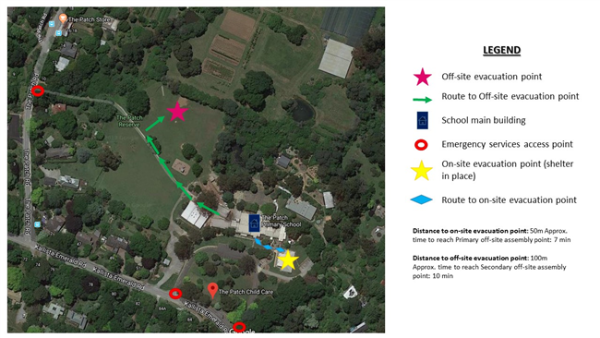

Evacuation Map
Building Name | Evacuation Procedures
NGARRERT Yr 5/6 Building | Listen and identify which type of evacuation it is and location. Follow the instructions given over the PA Refer to Evacuation Map located at doorway of room Assemble at evacuation point in an orderly fashion Listen to and follow the instructions from Chief Warden
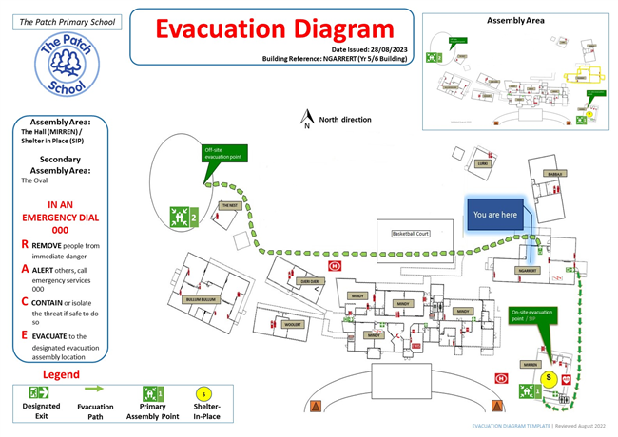
BABBAJI Art/STEM Room | Listen and identify which type of evacuation it is and location. Follow the instructions given over the PA Refer to Evacuation Map located at doorway of room Assemble at evacuation point in an orderly fashion Listen to and follow the instructions from Chief Warden
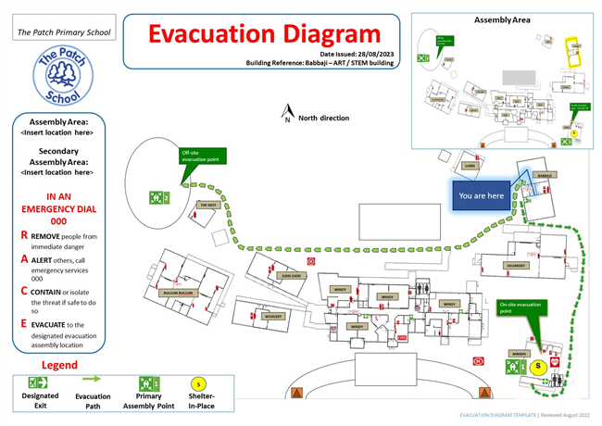
LURKI Music Room | Listen and identify which type of evacuation it is and location. Follow the instructions given over the PA Refer to Evacuation Map located at doorway of room Assemble at evacuation point in an orderly fashion Listen to and follow the instructions from Chief Warden
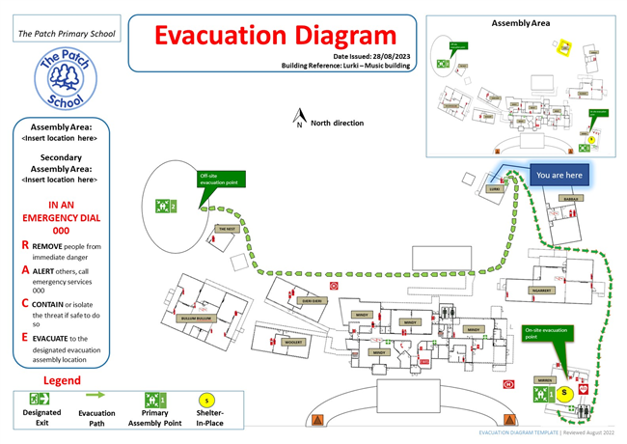
MINDY (MAIN OFFICE) | Listen and identify which type of evacuation it is and location. Follow the instructions given over the PA Refer to Evacuation Map located at doorway of room Assemble at evacuation point in an orderly fashion Listen to and follow the instructions from Chief Warden
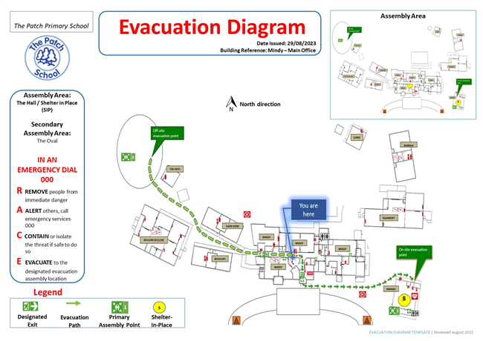
MINDY (PRINCIPAL OFFICE) | Listen and identify which type of evacuation it is and location. Follow the instructions given over the PA Refer to Evacuation Map located at doorway of room Assemble at evacuation point in an orderly fashion Listen to and follow the instructions from Chief Warden
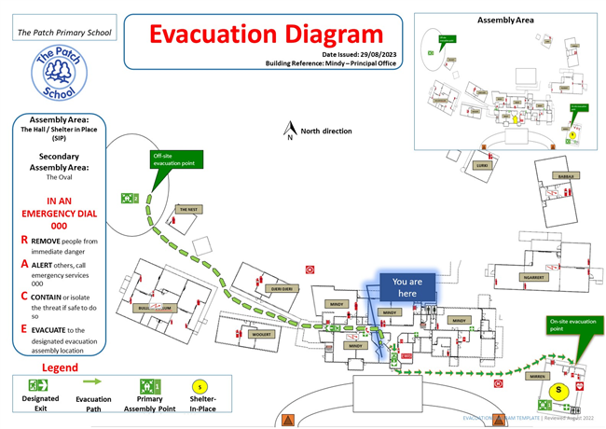
MINDY (STAFF ROOM) | Listen and identify which type of evacuation it is and location. Follow the instructions given over the PA Refer to Evacuation Map located at doorway of room Assemble at evacuation point in an orderly fashion Listen to and follow the instructions from Chief Warden
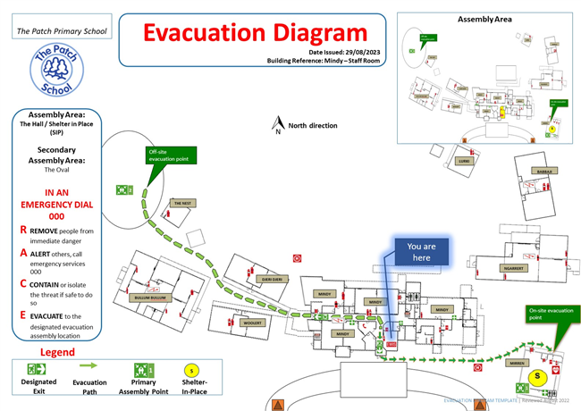
MINDY (Prep A) | Listen and identify which type of evacuation it is and location. Follow the instructions given over the PA Refer to Evacuation Map located at doorway of room Assemble at evacuation point in an orderly fashion Listen to and follow the instructions from Chief Warden
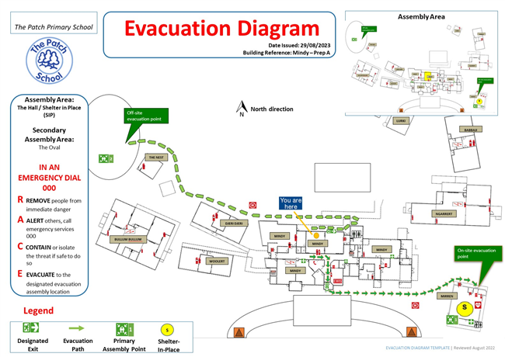
WOOLERT 1/2A & 1/2D | Listen and identify which type of evacuation it is and location. Follow the instructions given over the PA Refer to Evacuation Map located at doorway of room Assemble at evacuation point in an orderly fashion Listen to and follow the instructions from Chief Warden
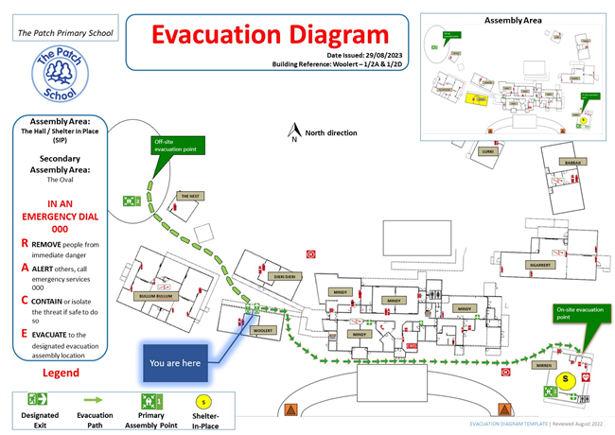
THE NEST | Listen and identify which type of evacuation it is and location. Follow the instructions given over the PA Refer to Evacuation Map located at doorway of room Assemble at evacuation point in an orderly fashion Listen to and follow the instructions from Chief Warden
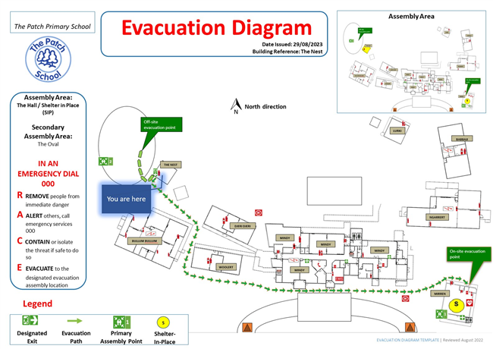
BULLUM BULLUM 3/4 Building | Listen and identify which type of evacuation it is and location. Follow the instructions given over the PA Refer to Evacuation Map located at doorway of room Assemble at evacuation point in an orderly fashion Listen to and follow the instructions from Chief Warden
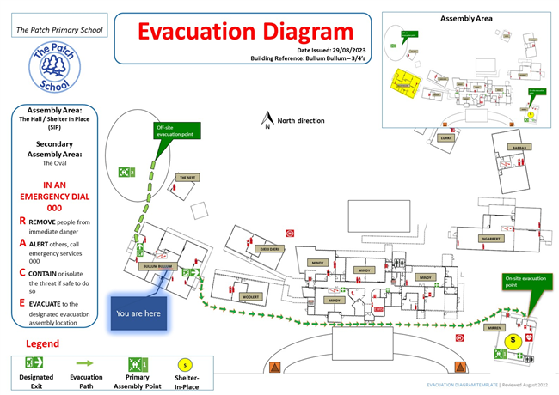
DJERI DJERI 1/2B & 1/2C | Listen and identify which type of evacuation it is and location. Follow the instructions given over the PA Refer to Evacuation Map located at doorway of room Assemble at evacuation point in an orderly fashion Listen to and follow the instructions from Chief Warden
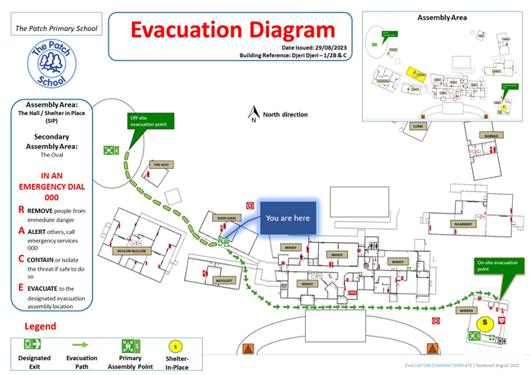
MINDY (STAFF RESOURCE ROOM) | Listen and identify which type of evacuation it is and location. Follow the instructions given over the PA Refer to Evacuation Map located at doorway of room Assemble at evacuation point in an orderly fashion Listen to and follow the instructions from Chief Warden
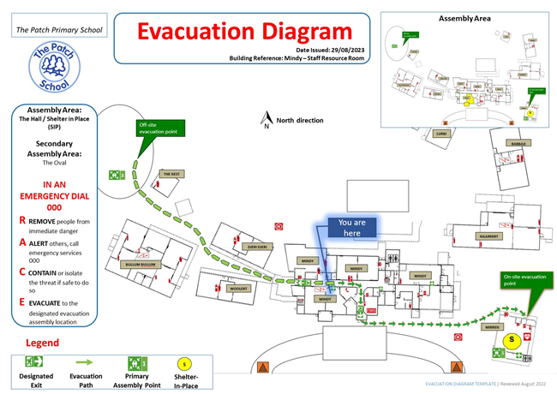
MINDY (LIBRARY) | Listen and identify which type of evacuation it is and location. Follow the instructions given over the PA Refer to Evacuation Map located at doorway of room Assemble at evacuation point in an orderly fashion Listen to and follow the instructions from Chief Warden
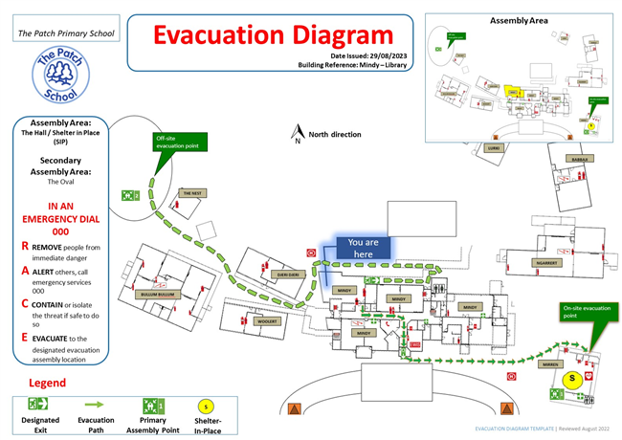
MINDY (Prep B) | Listen and identify which type of evacuation it is and location. Follow the instructions given over the PA Refer to Evacuation Map located at doorway of room Assemble at evacuation point in an orderly fashion Listen to and follow the instructions from Chief Warden
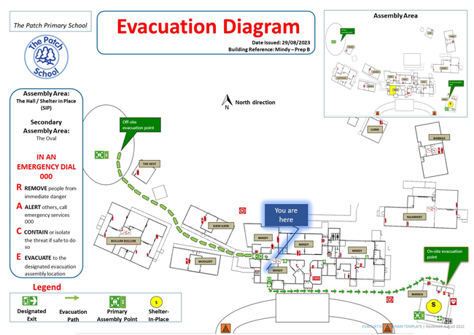
MINDY (Tutoring Room / Office) | Listen and identify which type of evacuation it is and location. Follow the instructions given over the PA Refer to Evacuation Map located at doorway of room Assemble at evacuation point in an orderly fashion Listen to and follow the instructions from Chief Warden
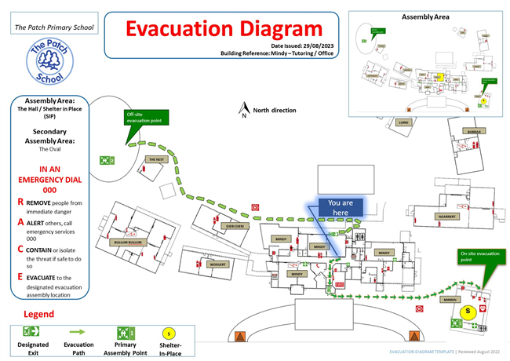

Distribution List
Name | Position Title and Organisation Name | Communication Date | Email or Postal Address
James Burnside | Principal The Patch School | 04/09/2023 | james.burnside@education.vic.gov.au
Michelle Rayner | Assistant Principal The Patch School | 04/09/2023 | michelle.rayner@education.vic.gov.au
Kim Small | Office Manager The Patch School | 04/09/2023 | Kim.Small@education.vic.gov.au
Karen Koelewyn | Business Manager The Patch School | 04/09/2023 | karen.koelewyn@education.vic.gov.au
Peter Toender | Captain Kallista-The Patch Fire Brigade (CFA) | 04/09/2023 | pctoender@gmail.com
Sgt Luke Schroder | Sergeant Monbulk Police (VicPol) | 04/09/2023 | monbulk.uni@police.vic.gov.au
Kym Mallamaci | Municipal Emergency Response Co-ordinator Shire of Yarra Ranges | 04/09/2023 | mail@yarraranges.vic.gov.au
TBA | Program Coordinator - OSHClub Pty Ltd | 04/09/2023 | thepatch@oshclub.com.au
All School Staff | All School Staff | 04/09/2023 | DL email list
South East Area Manager | Sparkways - Kinder Provider | 04/09/2023 | jennifer.cuthbertson@sparkways.org.au
Jo Rouse | Sparkways- The Patch Kinder Teacher | 04/09/2023 | Joanne.Rouse@try.org.au
Tradeflex | Cleaning Company | 04/09/2023 | nstones@tradeflex.com.au

